Table of Contents

Chapter 1: Introduction to the Problem 1

Introduction 2

Purpose 2

Objective 2

Existing solution 2

Purposed solution 3

Chapter 2: Software Requirement Specification 3

1. Introduction 4

1.1 Purpose 4

1.2 Scope 4

1.3. Definitions, acronyms, and abbreviations 4

1.4. References 5

1.5. Overview 5

1.2. Overall description 5

1.2.1. Product perspective 5

1.3. Product functions 6

1.4. User characteristics 13

1.5. Constraints 13

1.6. Assumptions and dependencies 13

1.7. Apportioning of requirements 14

2. SPECIFIC REQUIRMENTS 14

2.1. Functional Requirement 14

2.2. Non Functional Requirement 14

2.2.1. Usability 14

2.2.2. Reliabilit 14

2.2.3. Performance 14

2.2.4. Design constraints 14

2.2.5. Portability 14

2.2.6. Security 15

2.2.7. Maintainability 15

2.2.8. License Agreement 15

Chapter 3: Use Case Analysis 16

3.1. Register 17

3.2. User/admin login 18

3.3. Package 19

3.4. Individual or Group Package 20

3.5. Add Individual or Group Custom Package 20

3.6. Update Individual or Group Package 22

3.7. Delete Individual or Group Package 23

3.8. Flight information 24

3.9. Add Flight information 24

3.10. Update Flight information 25

3.11. Delete flight information 26

3.12. Flight class 27

3.13. Seat Conformation flight 28

3.14. Insurance 29

3.15. Travel insurance 30

3.16. Flight insurance 31

3.17. User / admin logout 32

3.18. Add hotel information 32

3.19. Delete hotel information 33

3.20. Update hotel information 34

3.21. Add flight information 35

3.22. Delete flight information 36

3.23. Update flight information 37

3.24. Add rent a car with driver information 38

3.25. Delete rent a car with driver information 39

3.26. Update rent a car with driver information 40

3.27. Add rent a car without driver 41

3.28. Delete rent a car without driver 42

3.29. Update rent a car without driver 43

3.31. Book package 44

3.32. Transfer payment 45

3.33. Forget password 46

Chapter 4: Design 47

4.1. Architecture Diagram 48

4.2. ERD with data dictionary 49

4.3. Data Flow diagram 50

4.3.1. Level 0 50

4.3.2. Level 1 51

4.4. Class Diagram 52

4.5. Activity Diagram 53

4.5.1. Register 53

4.5.2. Login 53

4.5.4. Destination Location 54

4.5.5. Check in 54

4.5.6. Check out 55

4.5.8. Select Package 57

4.5.9. Generic Package 58

4.5.11. Select Airline 59

4.5.12. Ticket Class 59

4.5.13. Select Hotel 60

4.5.14. Number of Rooms 60

4.5.15. Room Type 61

4.5.16. Rentals 61

4.5.17. Type of Vehicle 62

4.5.18. Insurance 62

4.5.18. Type of Insurance 63

4.5.19. Generic Package 63

4.5.20. Available Packages 64

4.5.21. Logout 64

4.6. Sequence Diagram 65

4.6.1 Sequence diagram for register 65

4.6.2 Sequence diagram for login 66

4.6.3 Sequence diagram for forget password 67

4.6.4 Sequence diagram for view individual package 68

4.6.5 Sequence diagram for admin add individual package 68

4.6.6 Sequence diagram for admin delete individual package 70

4.6.7 Sequence diagram for admin update individual package 71

4.6.8 Sequence diagram for view group package 71

4.6.9 Sequence diagram for admin delete group package 72

4.6.10 Sequence diagram for admin add group package 74

4.6.11 Sequence diagram for admin update group package 75

4.6.12 Sequence diagram for user fill his requirements 76

4.6.13 Sequence diagram for user to fill his requirements for custom packages 77

4.6.14 Sequence diagram for user to book the custom packages 77

4.6.15 Sequence diagram for user to transfer the money 78

4.6.16 Sequence diagram for user logout 79

4.6.17 Sequence diagram for admin add the accommodation information 80

4.6.18 Sequence diagram for admin delete the accommodation information 82

4.6.19 Sequence diagram for admin update the accommodation information 83

4.6.20 Sequence diagram for admin add the flight information 84

4.6.21 Sequence diagram for admin delete the flight information 85

4.6.22 Sequence diagram for admin update the flight information 86

4.6.23 Sequence diagram for admin add the insurance information 87

4.6.24 Sequence diagram for admin delete the insurance information 88

4.6.25 Sequence diagram for admin update the insurance information 89

4.6.26 Sequence diagram for admin add the rental information 90

4.6.27 Sequence diagram for admin delete the rental information 91

4.6.28 Sequence diagram for admin update the rental information 92

4.6.29 Sequence diagram for admin logout 93

4.7. Collaboration Diagram 94

4.8. State Transition Diagram 95

4.9. Component Diagram 96

4.10. Deployment Diagram 97

Chapter 1: Introduction to the Problem

# 

# Introduction

A lot of people are passionate about traveling but they cannot follow their passion because the traveling packages they are offered are very expensive they lack the basic information required for their traveling needs and even their safety needs are not satisfied. For traveling most people usually visit web portals or visit a travel agent. There are few already existing portals but they are not intelligent enough to provide them fully customized and intelligent solution. So there is serious need in the travel industry for custom package building mechanism/portal that is intelligent enough in real time and can offer interesting and desired advice.

# Purpose

The development of this project is to provide fully customized packages for travel passionate people and to make travel as safe as possible. Our portal will help people pre plan their trip in an easy way by providing them the intelligent advise in order to make their journey memorable, pleasurable and most of them all without compromising their insured safety nets.

# Objective

Customer satisfaction and trust is our main objective in order to achieve our objectives we make trips memorable, comfortable and pleasurable by providing them fully customizable traveling packages.

# Existing solution

Trip Advisor, Cheap O Air, Make my Trip. These are the existing available solutions and they have certain limitations and need excess work. Mainly their packages are not customizable specially while travelling there are additional needs for insurance coverage and/or accommodation selection, and/or car rentals are planned.

# Purposed solution

Travely is an automated portal that is based on artificial intelligence techniques to data extraction from web and helps the person who is planning a trip. This platform will though help design custom packages: flight booking with stop-overs vs price, accommodation advice in each stop over, and also possibly if traveler can avail car rental facility and what type of insurance should be accepted. Using this platform we shall use techniques from AI, semantics and data mining to help develop this portal. Specially if a traveler needs a comprehensive travel plan.

Chapter 2: Software Requirement Specification

# 

# 1. Introduction

The following subsections of the system requirements specification (SRS) document provide an overview of the entire SRS which in being followed by the online Travel Agency website. As many travel agency websites are available but most of them just don’t provide full requirements of tourist. Our website is also based on travel agency which will fullfil the whole requirements of user in cheap and secure way. Our website includes custom packages. It includes all facilities that user need during their traveling..

## 1.1 Purpose

The Software Requirements Specification is designed to document and describe the agreement between the customer and the developer regarding the specification of the software product requested. The primary purpose is to provide a clear and descriptive “statement of user requirements” that can be used as a reference in further development of the software system. This document is broken into a number of sections used to logically separate the software requirements into easily referenced parts. This Software Requirements Specification aims to describe the Functionality, External interfaces, Attributes and Design Constraints imposed on Implementation of the software system described throughout the rest of the document. Throughout the description of the software system, the language and terminology used should unambiguous and consistent throughout the document.

This portion of document is intended for technical users and developers of “Travely” (Web Portal).

## 1.2 Scope

People want to travel yet they must go through different web based portals or go through travel agents, which in most cases don’t cater to their specific needs nor offer local packages. Travely is an automated portal that is based on artificial intelligence techniques to data extraction from web and helps the person who is planning a trip.

## 1.3. Definitions, acronyms, and abbreviations

* SRS - System Requirements Specifications.
* Laravel - Framework
* W3 School - Front End Development Reference.
* MySQL - Back End Development.
* PHP - core language for website.
* HTML - hypertext markup language.
* HTTP - hypertext transfer protocol.
* UML - unified modeling language.
* GUI - graphical user interface.
* DBMS - database management system.
* WWW - World Wide Web.

## 1.4. References

* **Laravel** <https://laravel.com/>
* **W3 school** [www.w3school.com/](http://www.w3school.com/)
* **MySQL - Back End Development.** <http://dev.mysql.com/doc/>

## 1.5. Overview

User can view all the packages which will be custom packages. User will provide information about required tour e.g.: insurance, flight type, accommodation type and rentals . Looking at required information system will built custom packages which will be on runtime.

# 1.2. Overall description

## 1.2.1. Product perspective

Our website is a reliable system especially built for the person who wants to seek the

Information related to the different tours, packages. It is standalone system that will provide custom package. Noticeable feature will include in this website that will not be present in the other website. Like the feature ofshowing custom packages using AI. User need to fill his requirements and packages will be shown. This feature is not present in all websites.

By using this website the user will not need any other platform to go and seek some information because we are going to provide such a platform which is sufficient for all the aspects related to travels.

* **System interfaces**

This website provides combined interface as landing page for users, where authorized users may login using their usernames and passwords. Every user has different access like administration have different access, users have different access, and visitors have different access.

* **User interfaces**
* **Hardware interfaces**

There is no such hardware which is used for SRS. There is a basic list of hardware which are common .

* **Computers**

To run website on browsers .

* **Mobiles**

For android or ios.

* **Internet devices**

Stable internet access is recommended. IP/domain of the system must be allowed in firewall rules if applicable.

* **Software interfaces**

The “[www.travely.com](http://www.travely.com)” uses JavaScript and various functionality of PHP to meet the Requirements. Front End shall be developed in html5 and CSS which communicates to backend server using PHP and its support libraries.Framework use for this all will be Laravel .

* **Communications interfaces**

HTTP, FTP, and Interconnection.

* **Memory**

**RAM:**6GB

**Minimum database space:**10GB

* **Site adaptation requirements**

Web browser with cookies enabled.

## 1.3. Product functions

This platform will though help design custom packages: flight booking with stop-overs vs price, accommodation advice in each stop over, and also possibly if traveler can avail car rental facility and what type of insurance should be accepted. Using this platform we shall use techniques from AI, semantics and data mining to help develop this portal. Specially if a traveler needs a comprehensive travel plan.

**ID: FR_001**

**Name: Add the starting point location**

|  |  |  |  |
| --- | --- | --- | --- |
| Description | Input | Output | Work Flow |
| Add the starting point of journey | Enter the current location | Track the location | Enter the details or track by GPS |

**ID: FR_002**

**Name: Add the destination point location**

|  |  |  |  |
| --- | --- | --- | --- |
| Description | Input | Output | Work Flow |
| Add the destination point of journey | Enter the destination point | Track the destination point from database | Search for entered destination |

**ID: FR_003**

**Name: Departure Date**

|  |  |  |  |
| --- | --- | --- | --- |
| Description | Input | Output | Work Flow |
| Enter departure date | Select the date from poped calendar | Mark the date as destination | Mark the selected date for departure |

**ID: FR_004**

**Name: Return Date**

|  |  |  |  |
| --- | --- | --- | --- |
| Description | Input | Output | Work Flow |
| Enter return date | Select the date from pooped calendar | Mark the date as return | Mark the selected date for return |

**ID: FR_005**

**Name: Number of Persons**

|  |  |  |  |
| --- | --- | --- | --- |
| Description | Input | Output | Work Flow |
| Ask user the number of adults and children in a dropdown menu | Add or Subtract number of adults and children in given menu | Save number of persons | Select number of adults and children from a menu and save |

**ID: FR_006**

**Name: Hotel**

|  |  |  |  |
| --- | --- | --- | --- |
| Description | Input | Output | Work Flow |
| Select hotel on the base of destination | Click on hotel  Icon  Selection of hotel | Hotel selected | The user will select the hotel and it will be marked as selected |

**ID: FR_007**

**Name: Room**

|  |  |  |  |
| --- | --- | --- | --- |
| Description | Input | Output | Work Flow |
| Select no of rooms | Selection of room | Rooms selected | Select number of rooms from a dropdown menu |

**ID: FR_008**

**Name: Room Type**

|  |  |  |  |
| --- | --- | --- | --- |
| Description | Input | Output | Work Flow |
| Select type of room | Selection of room type | Given type of rooms i.e single bed, double bed, presidential suite | Select types of rooms from a dropdown menu |

**ID: FR_009**

**Name: Flight**

|  |  |  |  |
| --- | --- | --- | --- |
| Description | Input | Output | Work Flow |
| Select Flight | Click on Flight Icon | Selected flight | Enter the details of flights |

**ID: FR_010**

**Name: select flight class**

|  |  |  |  |
| --- | --- | --- | --- |
| Description | Input | Output | Work Flow |
| Select type of flight class | Selection type of class | Selected class  E.g. Economy, Premium, Business class, First class | Select class of flights from a dropdown menu |

**ID: FR_011**

**Name: Save Conformation Flight**

|  |  |  |  |
| --- | --- | --- | --- |
| Description | Input | Output | Work Flow |
| Click the save button | Book the Seat | Conformation the booking with popup message | Upon Selection of flights details |

**ID: FR_012**

**Name: Save Conformation Hotels**

|  |  |  |  |
| --- | --- | --- | --- |
| Description | Input | Output | Work Flow |
| Click the save button | Book the hotel | Conformation the booking with popup message | Upon Selection of hotel details |

**ID: FR_013**

**Name: Save Conformation Rooms**

|  |  |  |  |
| --- | --- | --- | --- |
| Description | Input | Output | Work Flow |
| Click the save button | Book the room | Conformation the booking with popup message | Upon Selection of room details |

**ID: FR_014**

**Name: Insurance**

|  |  |  |  |
| --- | --- | --- | --- |
| Description | Input | Output | Work Flow |
| If you want to avail the insurance then mark the insurance checkbox | Mark the checkbox | Show available options regarding insurance | Upon Selection of insurance details |

**ID: FR_015**

**Name: Select Travel Insurance**

|  |  |  |  |
| --- | --- | --- | --- |
| Description | Input | Output | Work Flow |
| If you want to avail the travel insurance then mark the insurance checkbox | Mark the travel insurance checkbox | Show available options regarding insurance | Upon Selection of travel insurance details |

**ID: FR_016**

**Name: Select Flight Insurance**

|  |  |  |  |
| --- | --- | --- | --- |
| Description | Input | Output | Work Flow |
| If you want to avail the flight insurance then mark the insurance checkbox | Mark the flight insurance checkbox | Show available options regarding insurance | Upon Selection of flight insurance details |

**ID: FR_017**

**Name: Rental Service**

|  |  |  |  |
| --- | --- | --- | --- |
| Description | Input | Output | Work Flow |
| If you want to avail the rental service then mark the rental service checkbox | Mark the rental service options | Show the list of rental services  E.g. Car, Motorbike, Van | Upon selection of rental service details |

**ID: FR_018**

**Name: Book packages**

|  |  |  |  |
| --- | --- | --- | --- |
| Description | Input | Output | Work Flow |
| When packages are shown then user will book the package | User click on book button | Process of money transfer will be shown | Upon selection of selected package |

**ID: FR_019**

**Name: Money transfer**

|  |  |  |  |
| --- | --- | --- | --- |
| Description | Input | Output | Work Flow |
| When packages are booked then user will transfer money by chosing suitable options for transfer | User select method of payment | Confirmation message of package will be shown | Upon selection of money transfer |

**ID: FR_020**

**Name: Search on given information**

|  |  |  |  |
| --- | --- | --- | --- |
| Description | Input | Output | Work Flow |
| When the user provides the basic information i.e departure, arrival, etc.  It will search on that information | User inputs the departure location and destination including the check in and check out dates for hotels | It will show all the information related to the trip i.e airways, hotels, rentals, insurances, driving license eligibility | On the input of the user information the system will provide the matching information related to the provided knowledge |

**ID: FR_21**

**Name: Search**

|  |  |  |  |
| --- | --- | --- | --- |
| Description | Input | Output | Work Flow |
| User will be provided with the options to search for any provided service it will be given option to search for a specific flight or hotel for a provided destination | User inputs the destination and the service which needs to be searched | The searched information will be provided to the user | The user will input the information and the system will search the database for the information available and if present provide it to the user |

## 1.4. User characteristics

A user of this system is defined as any living person who has a need for travel and knowledge to explore internet portals to search specifics and plan the whole trip, using all possible and available resources.

## 1.5. Constraints

A user might be in a situation where the package is not offered, or may face other political or economical situation, wherein such situation no promotions are identified.

## 1.6. Assumptions and dependencies

Our portal will only be web based and the user will be able to book the packages.

## 1.7. Apportioning of requirements

The online selling of the airline tickets and the booking of accommodations purchase of insurance policies and rentals will not be possible until it is fully functional and under the license which will be delayed until future version of the system.

# 2. SPECIFIC REQUIRMENTS

## 2.1. Functional Requirement

* Airline booking
* Hotel booking
* Rental services
* Insurances

## 2.2. Non Functional Requirement

### 2.2.1. Usability

The portal will be user friendly it will be designed by keeping the HCI basic principles to make the usability as effective as it can be. The designed interface will be easy to learn how to use and easy to remember how to use.

### 2.2.2. Reliability

The system is totally reliable to use by any user the data created in the system will be retained for a number of years without the data being changed by the system. The chances of system failure will be very low and in case if the system crashes it will have the ability to self recover.

### 2.2.3. Performance

The performance shall depend upon the Device’s processing speed, RAM and Screen Resolution. The internet speed is also necessary to obtain the high performance.

### 2.2.4. Design constraints

### 2.2.5. Portability

As this system is web based so the diversity of the hardware and software platforms on which the information system can run is very high as the system can run through any working computer or smart phone there is no special hardware or software requirement.

### 2.2.6. Security

The portal’s back-end servers shall only be accessible to authenticated administrators. The portal’s back-end databases shall be encrypted.

### 2.2.7. Maintainability

The source code developed for this portal shall be maintained in configuration management tool. Necessary changes will be made as per requirement.

### 2.2.8. License Agreement

As the system will be in development and evolution stages so there will be will be no license agreements of any kind

Chapter 3: Use Case Analysis

# 

# 3.1. Register

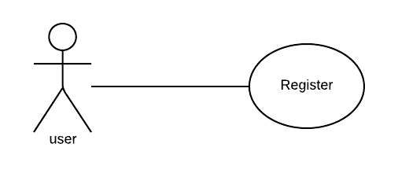

**Use case diagram detail:**

|  |  |
| --- | --- |
| Use Case ID | UC#01 |
| Use Case Name | Register |
| Description | Register to web portal |
| Primary Actor | User |
| Secondary Actor | Admin |
| Pre-Condition | none |
| Post-Condition | none |
| Basic Flow | Actor Action System Action |
|  | User Information. Register into Database  E.g. Name, cell No, Address, City... |
| Alternate Flow | none |

# 3.2. User/admin login

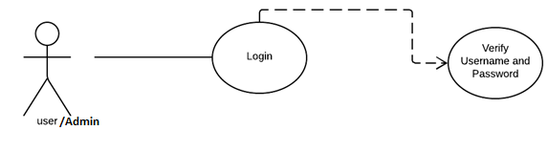

**Use case diagram detail:**

|  |  |
| --- | --- |
| Use Case ID | UC#02 |
| Use Case Name | Login |
| Description | Login to web portal |
| Primary Actor | User |
| Secondary Actor | Admin |
| Pre-Condition | none |
| Post-Condition | none |
| Basic Flow | Actor Action System Action |
|  | Input the username and password Return Output |
| Alternate Flow | none |

# 3.3. Package

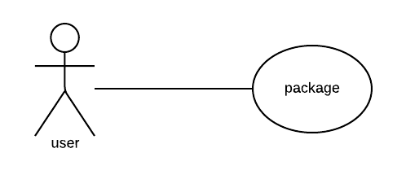

**Use case diagram detail:**

|  |  |
| --- | --- |
| Use Case ID | UC#03 |
| Use Case Name | Package |
| Description | Show the packages |
| Primary Actor | User |
| Secondary Actor | Admin |
| Pre-Condition | Must be login |
| Post-Condition | Internet |
| Basic Flow | Actor Action System Action |
|  | Click on packages Return the selection information |
| Alternate Flow | none |

# 3.4. Individual or Group Package

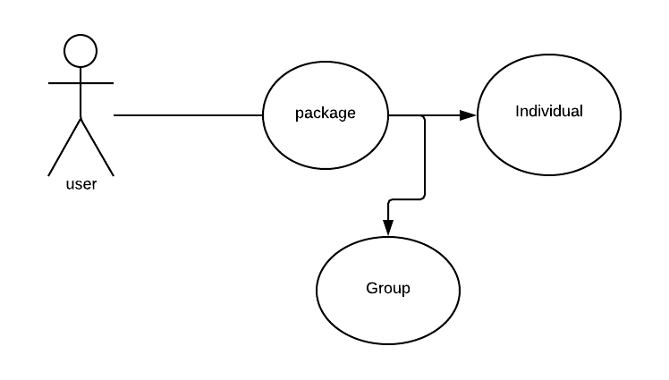

**Use case diagram detail:**

|  |  |
| --- | --- |
| Use Case ID | UC#04 |
| Use Case Name | individual or Group Package |
| Description | Store the individual or group package in database |
| Primary Actor | User |
| Secondary Actor | Admin |
| Pre-Condition | Must be login |
| Post-Condition | none |
| Basic Flow | Actor Action System Action |
|  | Select Individual or Group Return the selection information |
| Alternate Flow | none |

# 

# 3.5. Add Individual or Group Custom Package

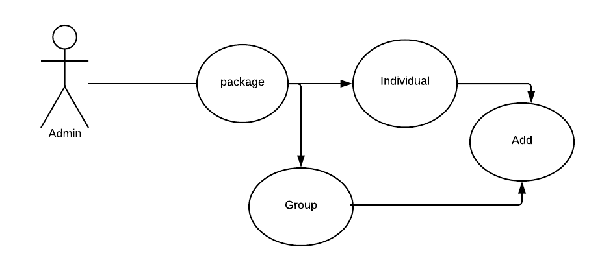

**Use case diagram detail:**

|  |  |
| --- | --- |
| Use Case ID | UC#05 |
| Use Case Name | Add individual or Group Package |
| Description | Save the individual or Group Package in database |
| Primary Actor | User |
| Secondary Actor | Admin |
| Pre-Condition | Must be login |
| Post-Condition | none |
| Basic Flow | Actor Action System Action |
|  | Add Custom Package Store the Package |
| Alternate Flow | none |

# 3.6. Update Individual or Group Package

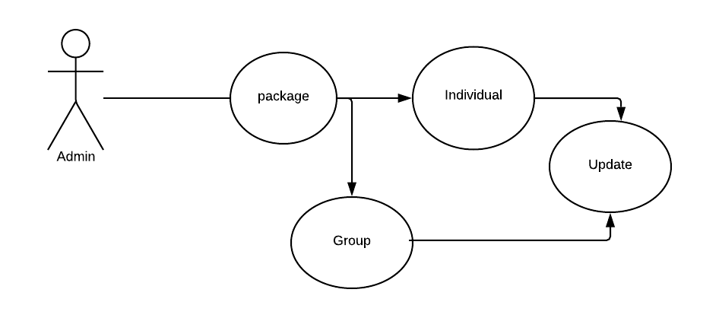

**Use case diagram detail:**

|  |  |
| --- | --- |
| Use Case ID | UC#06 |
| Use Case Name | Update individual or Group packages |
| Description | Edit the individual or Group packages in database |
| Primary Actor | User |
| Secondary Actor | none |
| Pre-Condition | Must be login |
| Post-Condition | none |
| Basic Flow | Actor Action System Action |
|  | Update the information Return and store information |
| Alternate Flow | none |

# 3.7. Delete Individual or Group Package

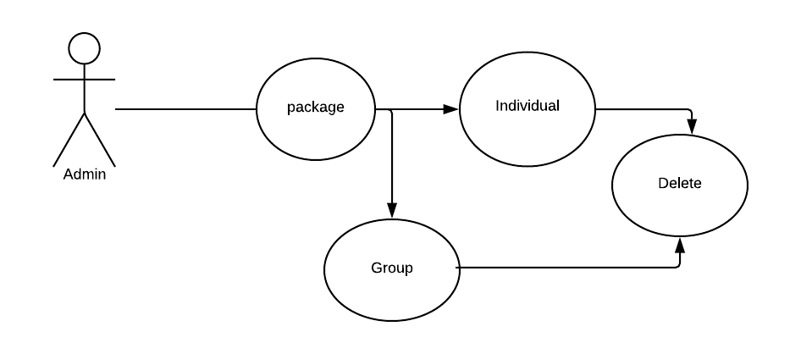

**Use case diagram detail:**

|  |  |
| --- | --- |
| Use Case ID | UC#07 |
| Use Case Name | Delete Individual or Group Package |
| Description | Delete the Individual or Group Package from database |
| Primary Actor | User |
| Secondary Actor | none |
| Pre-Condition | Must be login |
| Post-Condition | none |
| Basic Flow | Actor Action System Action |
|  | Select and delete delete the Package |
| Alternate Flow |  |

# 3.8. Flight information

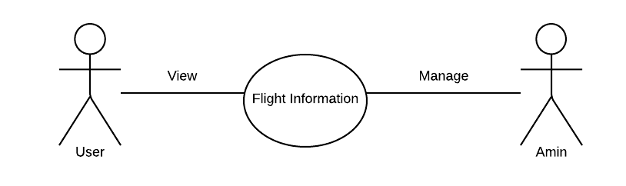

**Use case diagram detail:**

|  |  |
| --- | --- |
| Use Case ID | UC#08 |
| Use Case Name | Flight’s information |
| Description | View the Flight’s |
| Primary Actor | User |
| Secondary Actor | Admin |
| Pre-Condition | Must be login |
| Post-Condition | internet |
| Basic Flow | Actor Action System Action |
|  | Select the Flight Return the selection information |
| Alternate Flow | none |

# 3.9. Add Flight information

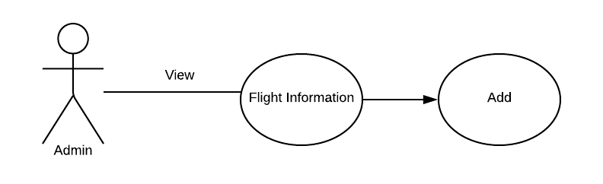

**Use case diagram detail:**

|  |  |
| --- | --- |
| Use Case ID | UC#09 |
| Use Case Name | Add Flight’s information |
| Description | Add new flight’s information |
| Primary Actor | Admin |
| Secondary Actor | None |
| Pre-Condition | Must be login |
| Post-Condition | Internet |
| Basic Flow | Actor Action System Action |
|  | Add new Return the information |
| Alternate Flow | none |

# 3.10. Update Flight information

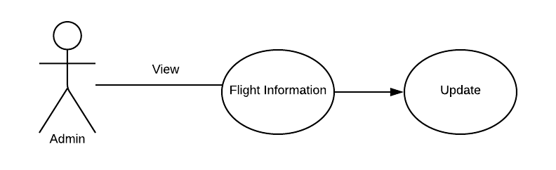

**Use case diagram detail:**

|  |  |
| --- | --- |
| Use Case ID | UC#10 |
| Use Case Name | Update Flight’s information |
| Description | Update the Flight’s information |
| Primary Actor | Admin |
| Secondary Actor | none |
| Pre-Condition | Must be login |
| Post-Condition | Internet |
| Basic Flow | Actor Action System Action |
|  | Select and update Return the selection information |
| Alternate Flow | none |

# 3.11. Delete flight information

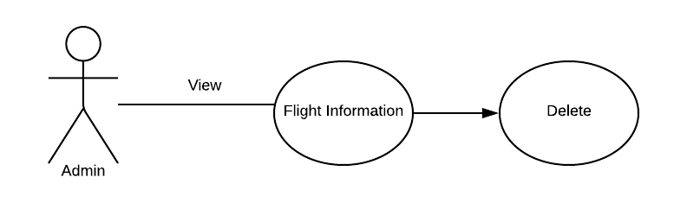

**Use case diagram detail:**

|  |  |
| --- | --- |
| Use Case ID | UC#11 |
| Use Case Name | Delete Flight’s information |
| Description | Delete the flight’s information |
| Primary Actor | User |
| Secondary Actor | None |
| Pre-Condition | Must be login |
| Post-Condition | Internet |
| Basic Flow | Actor Action System Action |
|  | Delete the flight delete the selection information |
| Alternate Flow | none |

# 3.12. Flight class

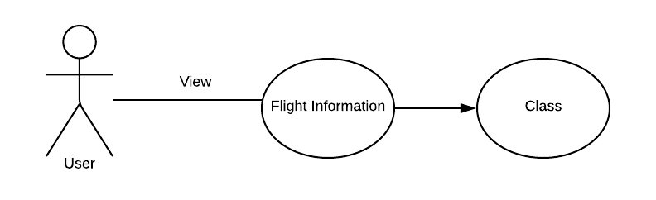

**Use case diagram detail:**

|  |  |
| --- | --- |
| Use Case ID | UC#12 |
| Use Case Name | Flight’s Class |
| Description | Select type of flight class |
| Primary Actor | User |
| Secondary Actor | None |
| Pre-Condition | Must be login |
| Post-Condition | Internet |
| Basic Flow | Actor Action System Action |
|  | Selection type of class Return the Selection information |
| Alternate Flow | none |

# 3.13. Seat Conformation flight

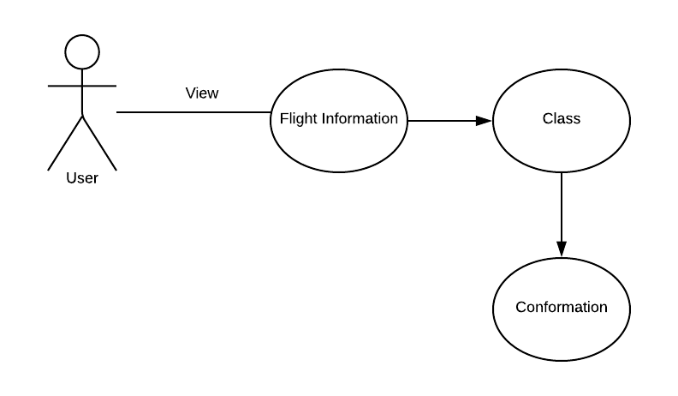

**Use case diagram detail:**

|  |  |
| --- | --- |
| Use Case ID | UC#13 |
| Use Case Name | Flight’s Conformation |
| Description | Click the save button |
| Primary Actor | User |
| Secondary Actor | None |
| Pre-Condition | Must be login |
| Post-Condition | Internet |
| Basic Flow | Actor Action System Action |
|  | Book the Seat Conformation the booking with  popup message |
| Alternate Flow | none |

# 3.14. Insurance

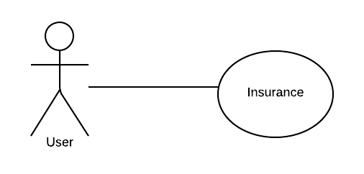

**Use case diagram detail:**

|  |  |
| --- | --- |
| Use Case ID | UC#14 |
| Use Case Name | Insurance |
| Description | If you want to avail the insurance then mark the insurance checkbox |
| Primary Actor | User |
| Secondary Actor | None |
| Pre-Condition | Must be login |
| Post-Condition | Internet |
| Basic Flow | Actor Action System Action |
|  | Mark the checkbox Show available options regarding  insurance |
| Alternate Flow | none |

# 3.15. Travel insurance

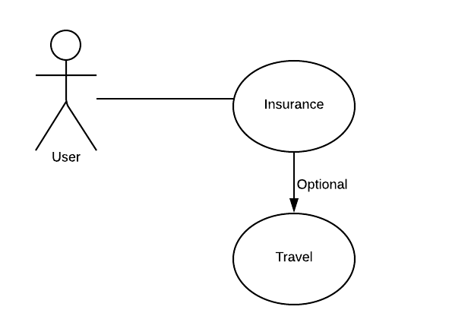

**Use case diagram detail:**

|  |  |
| --- | --- |
| Use Case ID | UC#15 |
| Use Case Name | Travel Insurance |
| Description | If you want to avail the travel insurance then mark the insurance checkbox |
| Primary Actor | User |
| Secondary Actor | None |
| Pre-Condition | Must be login |
| Post-Condition | Internet |
| Basic Flow | Actor Action System Action |
|  | Mark the travel insurance checkbox Show available options regarding  insurance |
| Alternate Flow | none |

# 3.16. Flight insurance

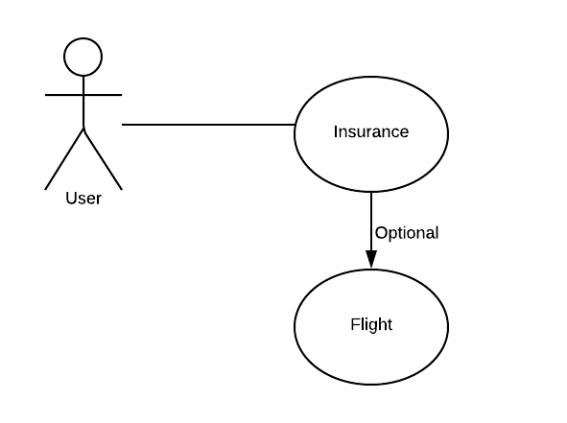

**Use case diagram detail:**

|  |  |
| --- | --- |
| Use Case ID | UC#16 |
| Use Case Name | Flight Insurance |
| Description | If you want to avail the flight insurance then mark the insurance checkbox |
| Primary Actor | User |
| Secondary Actor | None |
| Pre-Condition | Must be login |
| Post-Condition | Internet |
| Basic Flow | Actor Action System Action |
|  | Mark the flight insurance checkbox Show available options regarding  insurance |
| Alternate Flow | none |

# 3.17. User / admin logout

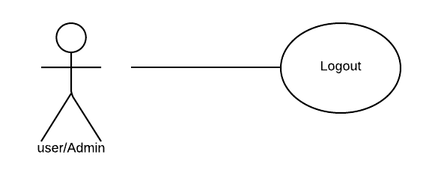

**Use case diagram detail:**

|  |  |
| --- | --- |
| Use Case ID | UC#17 |
| Use Case Name | Logout |
| Description | Logout from the Web Portal |
| Primary Actor | User/Admin |
| Secondary Actor | none |
| Pre-Condition | Must be login |
| Post-Condition | none |
| Basic Flow | Actor Action System Action |
|  | Click Logout Logout the user / Admin |
| Alternate Flow | none |

# 

# 3.18. Add hotel information

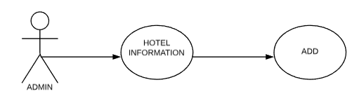

**Use case diagram detail:**

|  |  |
| --- | --- |
| Use Case ID | UC#18 |
| Use Case Name | Add Hotel’s information |
| Description | Add new hotel’s information in database |
| Primary Actor | Admin |
| Secondary Actor | None |
| Pre-Condition | Must be login |
| Post-Condition | Internet |
| Basic Flow | Actor Action System Action |
|  | Add new Return the information |
| Alternate Flow | none |

# 3.19. Delete hotel information

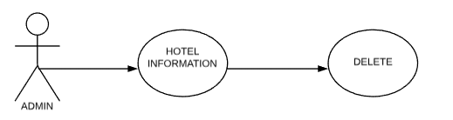

**Use case diagram detail:**

|  |  |
| --- | --- |
| Use Case ID | UC#19 |
| Use Case Name | Delete Hotel’s information |
| Description | Delete the hotel’s information from the database |
| Primary Actor | User |
| Secondary Actor | None |
| Pre-Condition | Must be login |
| Post-Condition | Internet |
| Basic Flow | Actor Action System Action |
|  | Delete the hotel delete the selection information |
| Alternate Flow | none |

# 3.20. Update hotel information

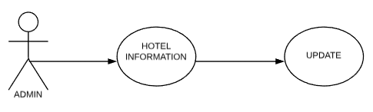

**Use case diagram detail:**

|  |  |
| --- | --- |
| Use Case ID | UC#20 |
| Use Case Name | Update Hotel’s information |
| Description | Update the Update Hotel’s information from database |
| Primary Actor | Admin |
| Secondary Actor | None |
| Pre-Condition | Must be login |
| Post-Condition | Internet |
| Basic Flow | Actor Action System Action |
|  | Select and update Return the selection information |
| Alternate Flow | None |

# 3.21. Add flight information

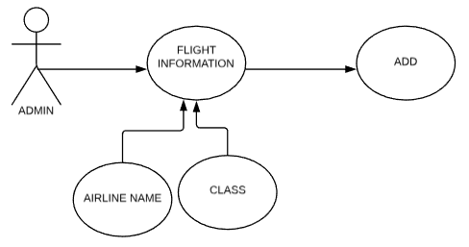

**Use case diagram detail:**

|  |  |
| --- | --- |
| Use Case ID | UC#21 |
| Use Case Name | Add Flight information |
| Description | Add Flight information to database |
| Primary Actor | Admin |
| Secondary Actor | None |
| Pre-Condition | Must be login |
| Post-Condition | Internet |
| Basic Flow | Actor Action System Action |
|  | Add New Add selection information |
| Alternate Flow | None |

# 3.22. Delete flight information

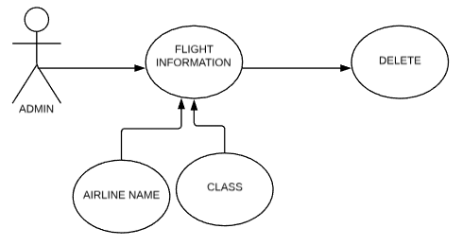

**Use case diagram detail:**

|  |  |
| --- | --- |
| Use Case ID | UC#22 |
| Use Case Name | Add Flight information |
| Description | Delete Flight information from database |
| Primary Actor | Admin |
| Secondary Actor | None |
| Pre-Condition | Must be login |
| Post-Condition | Internet |
| Basic Flow | Actor Action System Action |
|  | Select and delete Delete the selection information |
| Alternate Flow | None |

# 3.23. Update flight information

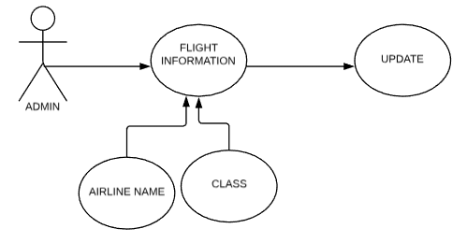

**Use case diagram detail:**

|  |  |
| --- | --- |
| Use Case ID | UC#23 |
| Use Case Name | Update Flight information |
| Description | Update Flight information from database |
| Primary Actor | Admin |
| Secondary Actor | None |
| Pre-Condition | Must be login |
| Post-Condition | Internet |
| Basic Flow | Actor Action System Action |
|  | Select and update Return the selection information |
| Alternate Flow | None |

# 3.24. Add rent a car with driver information

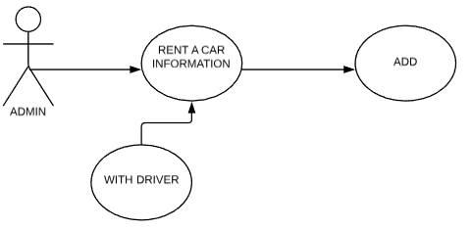

**Use case diagram detail:**

|  |  |
| --- | --- |
| Use Case ID | UC#24 |
| Use Case Name | Add Rent a car with driver information |
| Description | Add Rent a car with driver information to database |
| Primary Actor | Admin |
| Secondary Actor | None |
| Pre-Condition | Must be login |
| Post-Condition | Internet |
| Basic Flow | Actor Action System Action |
|  | Add new ADD information |
| Alternate Flow | None |

# 3.25. Delete rent a car with driver information

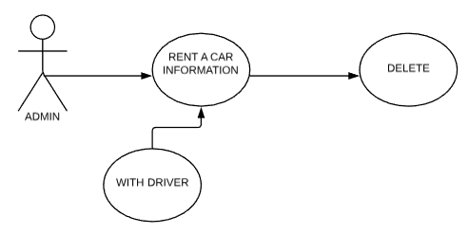

**Use case diagram detail:**

|  |  |
| --- | --- |
| Use Case ID | UC#25 |
| Use Case Name | Delete Rent a car with driver information |
| Description | Delete Rent a car with driver information from database |
| Primary Actor | Admin |
| Secondary Actor | None |
| Pre-Condition | Must be login |
| Post-Condition | Internet |
| Basic Flow | Actor Action System Action |
|  | Select and delete Delete the selection information |
| Alternate Flow | None |

# 3.26. Update rent a car with driver information

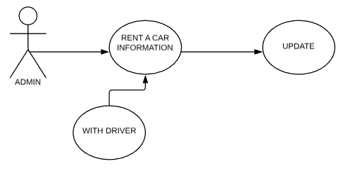

**Use case diagram detail:**

|  |  |
| --- | --- |
| Use Case ID | UC#26 |
| Use Case Name | Update Rent a car with driver information |
| Description | Update Rent a car with driver information from database |
| Primary Actor | Admin |
| Secondary Actor | None |
| Pre-Condition | Must be login |
| Post-Condition | Internet |
| Basic Flow | Actor Action System Action |
|  | Select and update Return the selection information |
| Alternate Flow | None |

# 3.27. Add rent a car without driver

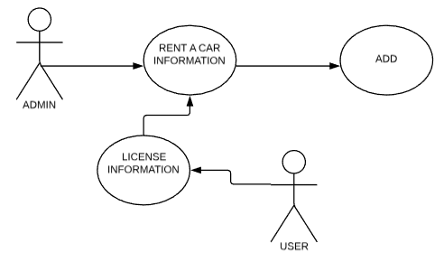

**Use case diagram detail:**

|  |  |
| --- | --- |
| Use Case ID | UC#27 |
| Use Case Name | Add Rent a car self-drive information |
| Description | Add Rent a car self-drive information to database |
| Primary Actor | Admin |
| Secondary Actor | User |
| Pre-Condition | Must be login |
| Post-Condition | Internet |
| Basic Flow | Actor Action System Action |
|  | Add new Add information |
| Alternate Flow | None |

# 3.28. Delete rent a car without driver

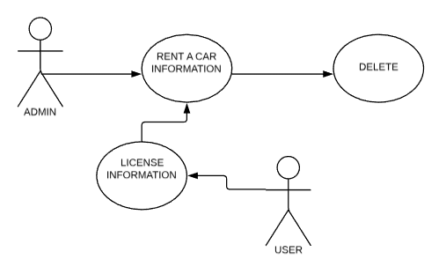

**Use case diagram detail:**

|  |  |
| --- | --- |
| Use Case ID | UC#28 |
| Use Case Name | Delete Rent a car self-drive information |
| Description | Delete Rent a car self-drive information from database |
| Primary Actor | Admin |
| Secondary Actor | User |
| Pre-Condition | Must be login |
| Post-Condition | Internet |
| Basic Flow | Actor Action System Action |
|  | Select and delete Delete the selection information |
| Alternate Flow | None |

# 3.29. Update rent a car without driver

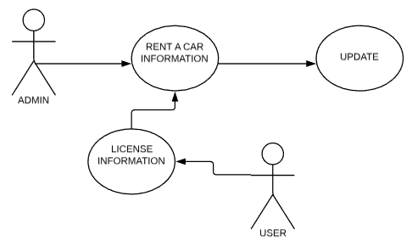

**Use case diagram detail:**

|  |  |
| --- | --- |
| Use Case ID | UC#29 |
| Use Case Name | Update Rent a car self-drive information |
| Description | Update Rent a car self-drive information from database |
| Primary Actor | Admin |
| Secondary Actor | User |
| Pre-Condition | Must be login |
| Post-Condition | Internet |
| Basic Flow | Actor Action System Action |
|  | Select and update Return the selection information |
| Alternate Flow | none |

**3.30. Show custom package**

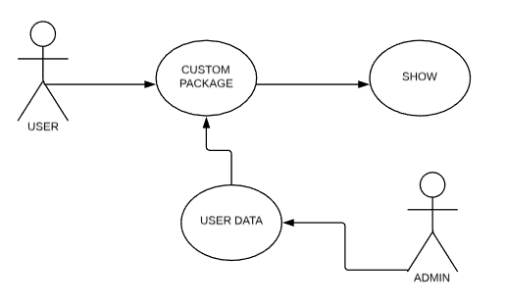

**Use case diagram detail:**

|  |  |
| --- | --- |
| Use Case ID | UC#30 |
| Use Case Name | Show custom package information |
| Description | Show custom package using AI |
| Primary Actor | User |
| Secondary Actor | Admin |
| Pre-Condition | Must be login |
| Post-Condition | Internet |
| Basic Flow | Actor Action System Action |
|  | Show packages Show information |
| Alternate Flow | none |

# 

# 3.31. Book package

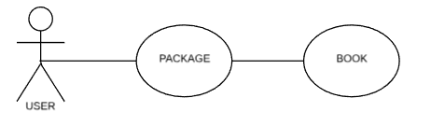

**Use case diagram detail:**

|  |  |
| --- | --- |
| Use Case ID | UC#31 |
| Use Case Name | Book package |
| Description | User book package |
| Primary Actor | User |
| Secondary Actor | None |
| Pre-Condition | Must be login |
| Post-Condition | Internet |
| Basic Flow | Actor Action System Action |
|  | Book package Ask for confirmation |
| Alternate Flow | none |

# 

# 3.32. Transfer payment

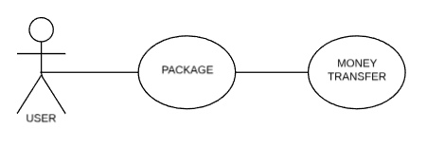

**Use case diagram detail:**

|  |  |
| --- | --- |
| Use Case ID | UC#32 |
| Use Case Name | TRANSFER MONEY |
| Description | User transfer money by selecting options |
| Primary Actor | User |
| Secondary Actor | None |
| Pre-Condition | Must be login |
| Post-Condition | Internet |
| Basic Flow | Actor Action System Action |
|  | Money transfer check account |
| Alternate Flow | none |

# 

# 3.33. Forget password

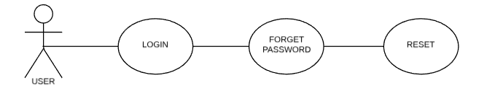

**Use case diagram detail:**

|  |  |
| --- | --- |
| Use Case ID | UC#33 |
| Use Case Name | Forget password |
| Description | Reset password by verification |
| Primary Actor | User |
| Secondary Actor | none |
| Pre-Condition | none |
| Post-Condition | Internet |
| Basic Flow | Actor Action System Action |
|  | Show mobile number Send verification code |
| Alternate Flow | none |

Chapter 4: Design

# 

# 4.1. Architecture Diagram

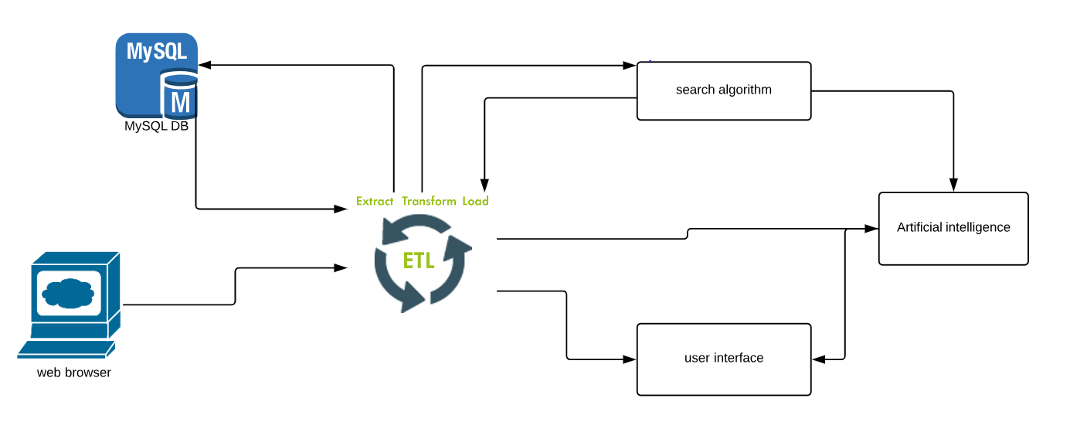

# 4.2. ERD with data dictionary

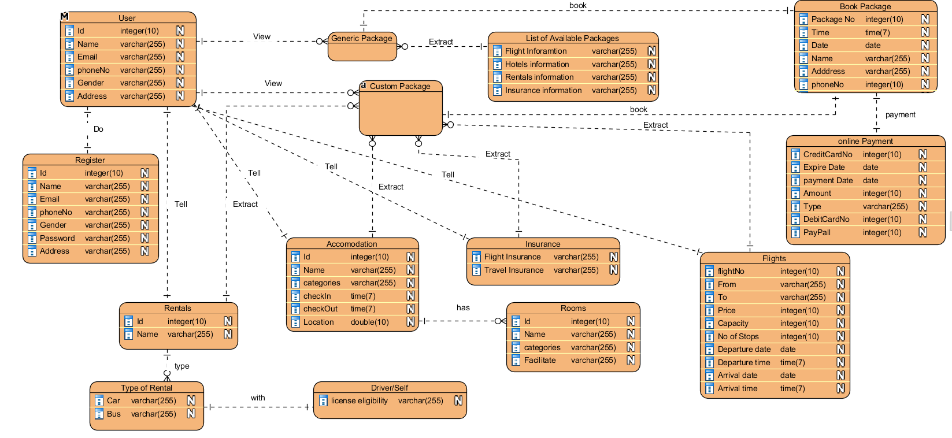

# 4.3. Data Flow diagram

## 4.3.1. Level 0

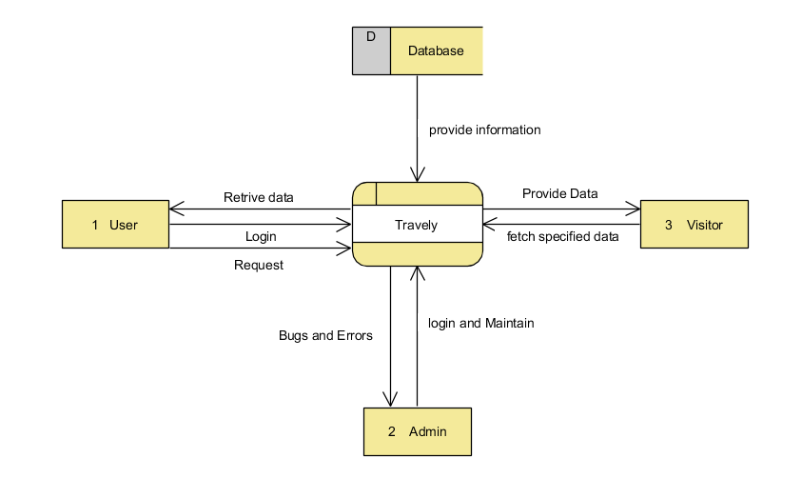

## 4.3.2. Level 1

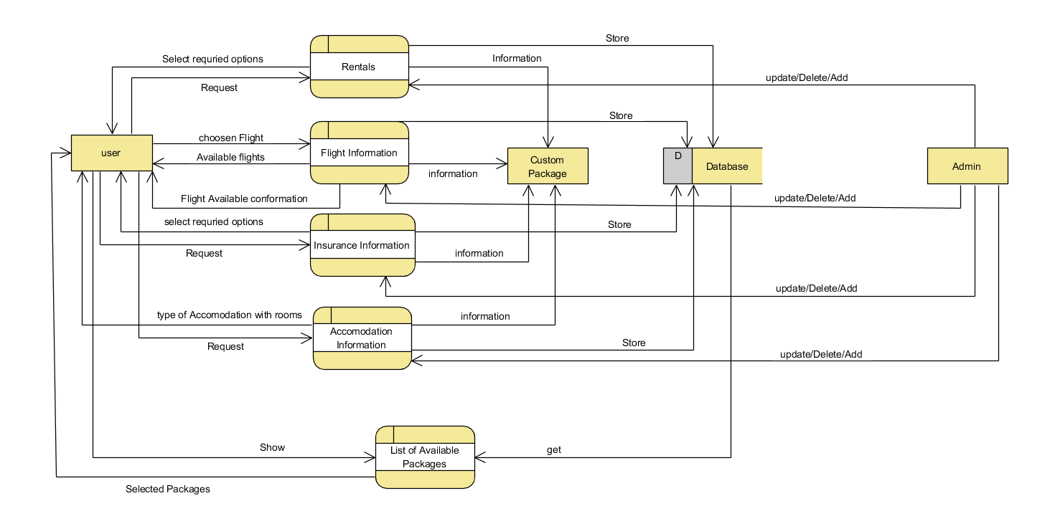

# 4.4. Class Diagram

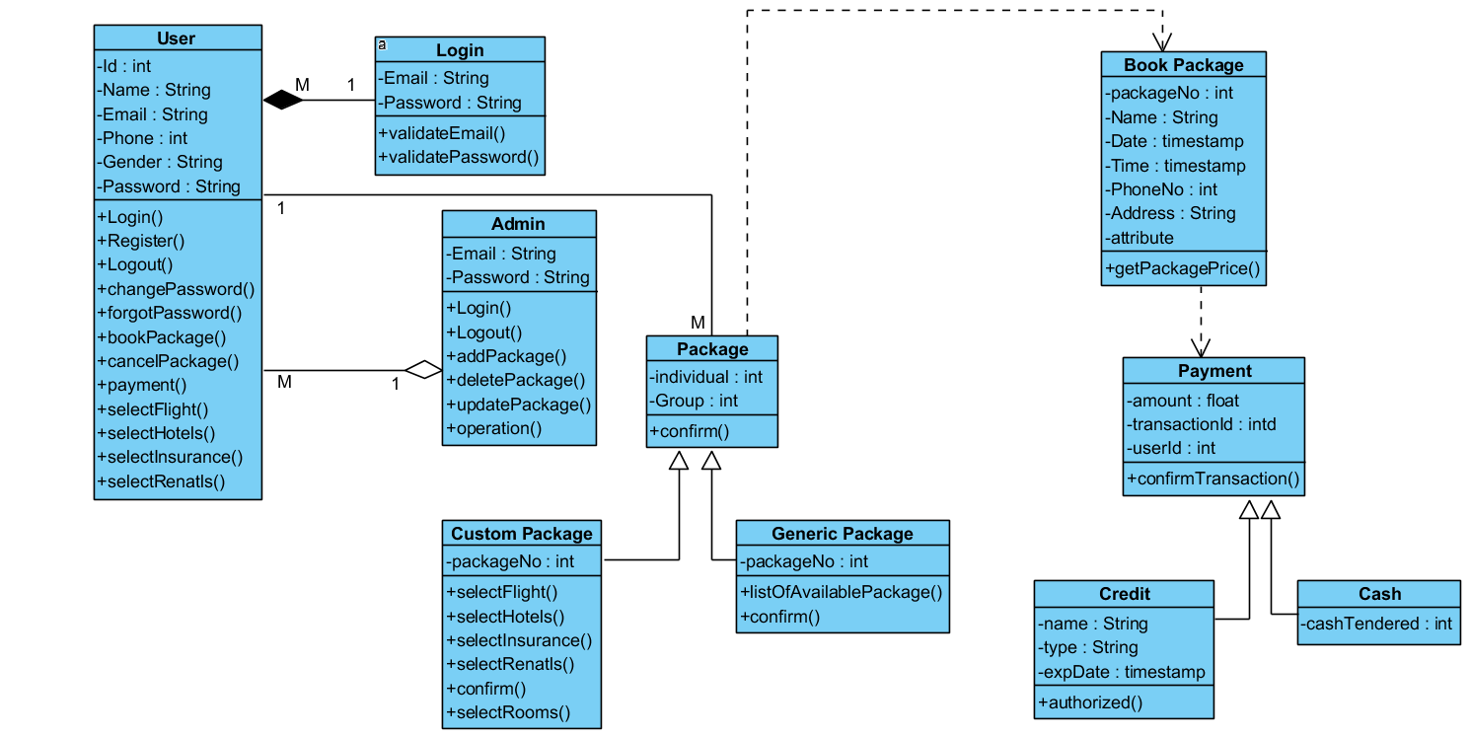

# 4.5. Activity Diagram

## 4.5.1. Register

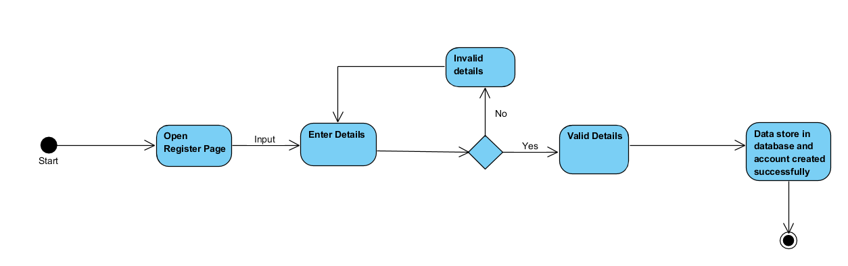

## 4.5.2. Login

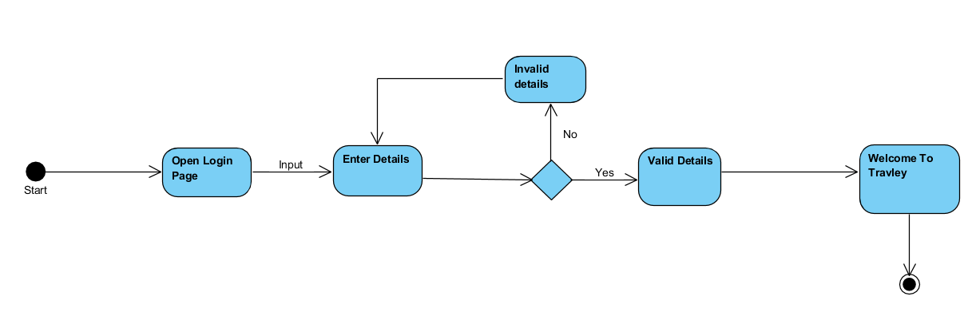4.5.3. Current Location

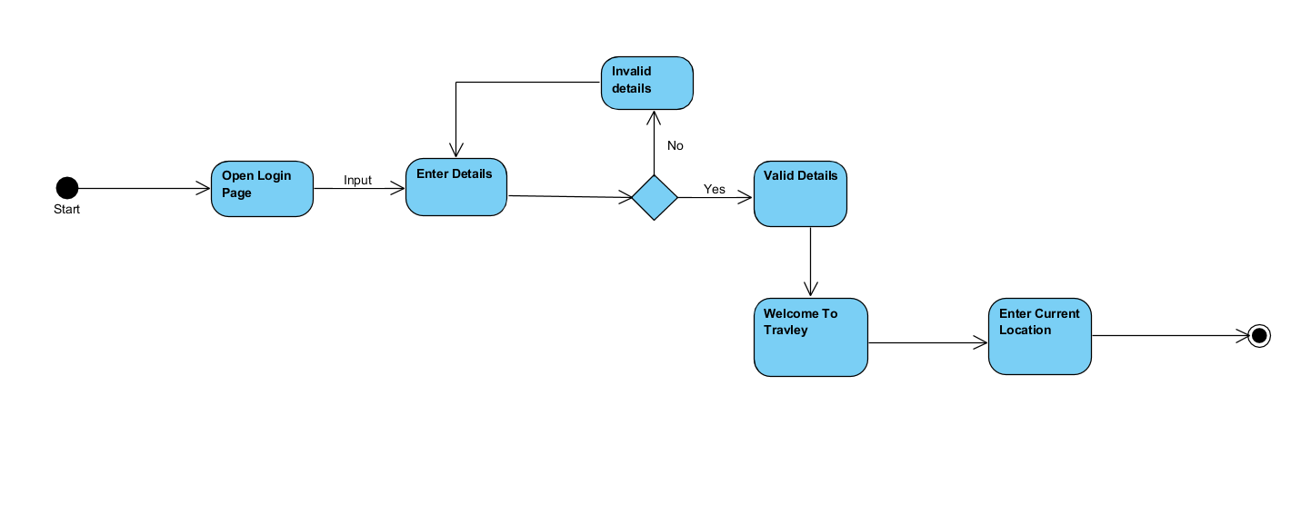

4.5.4. Destination Location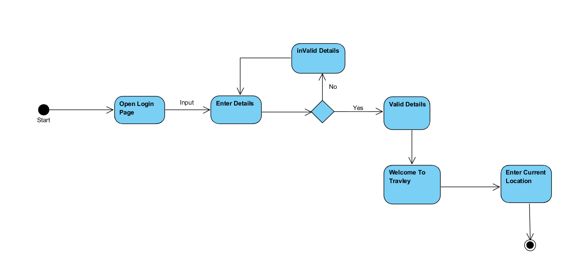

## 4.5.5. Check in

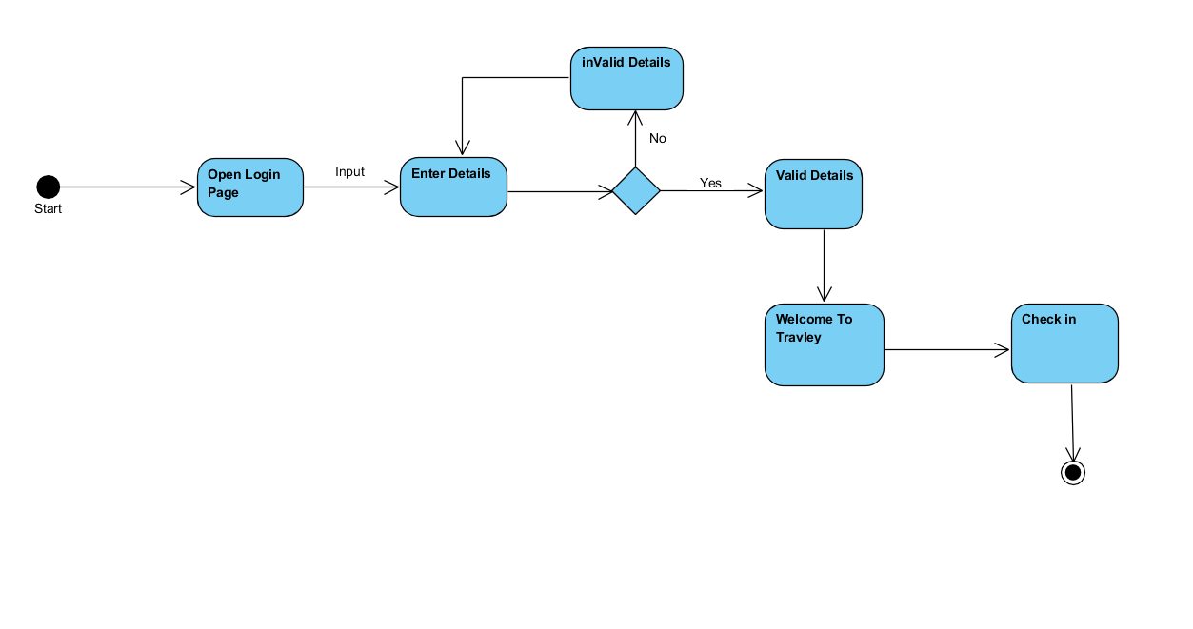

4.5.6. Check out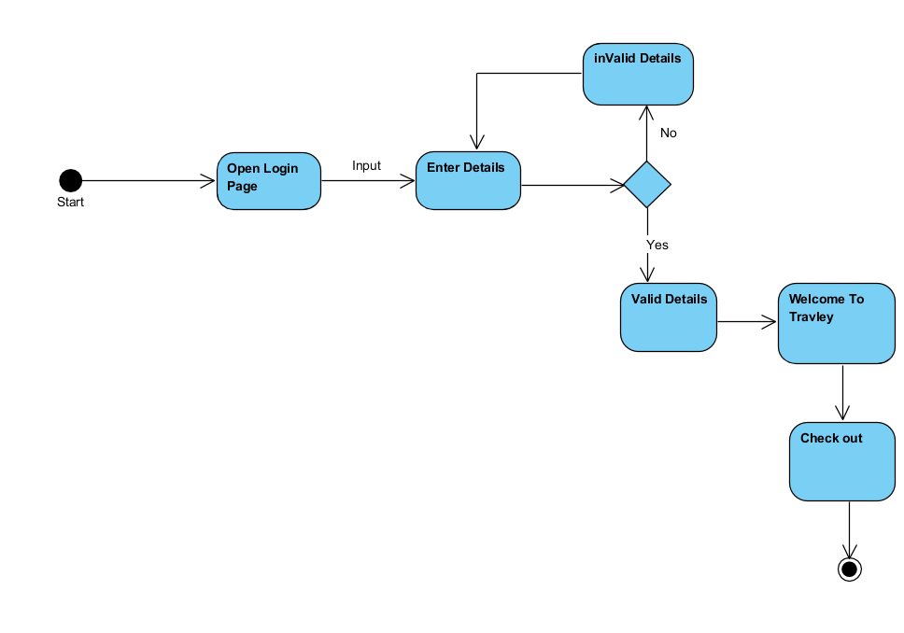4.5.7. Number of Person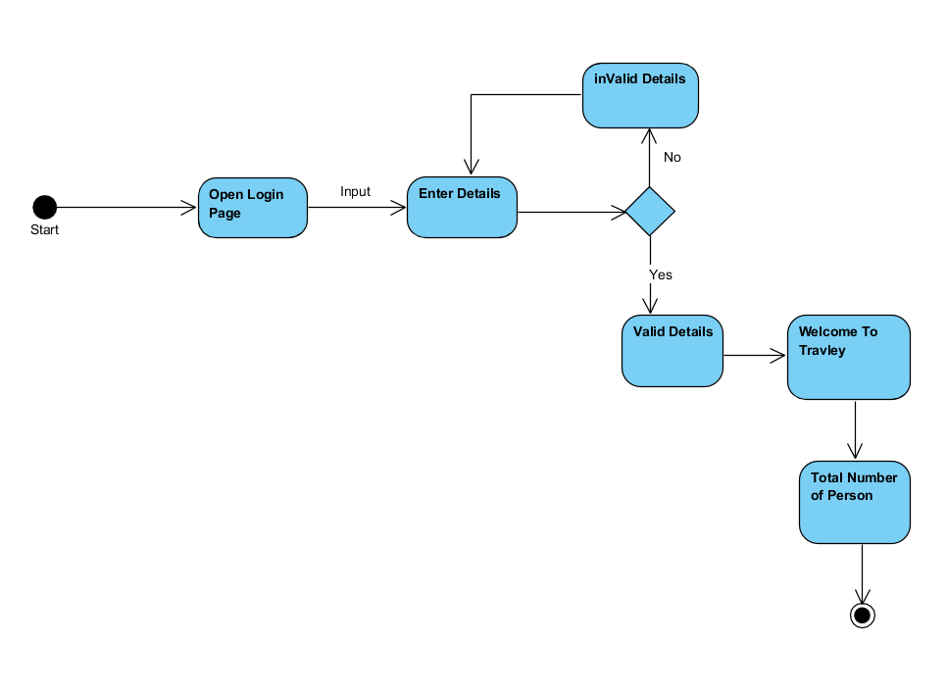

## 4.5.8. Select Package

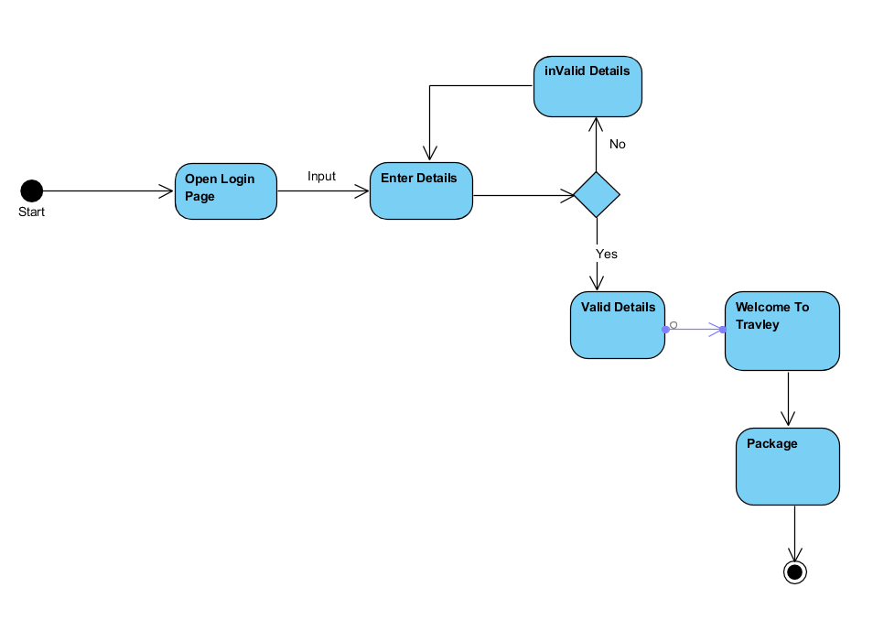

## 4.5.9. Generic Package

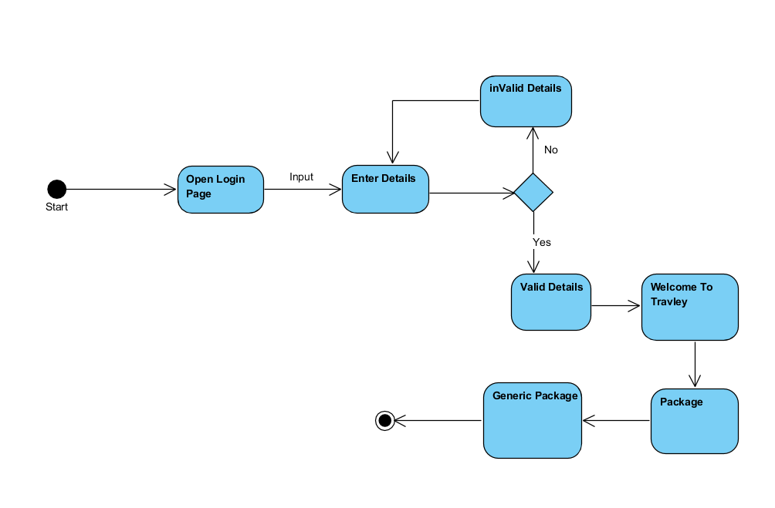4.5.10. Custom Package

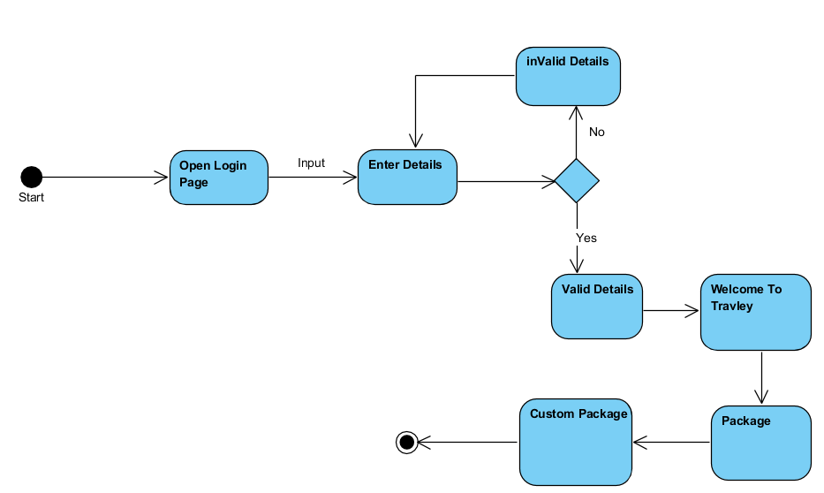

4.5.11. Select Airline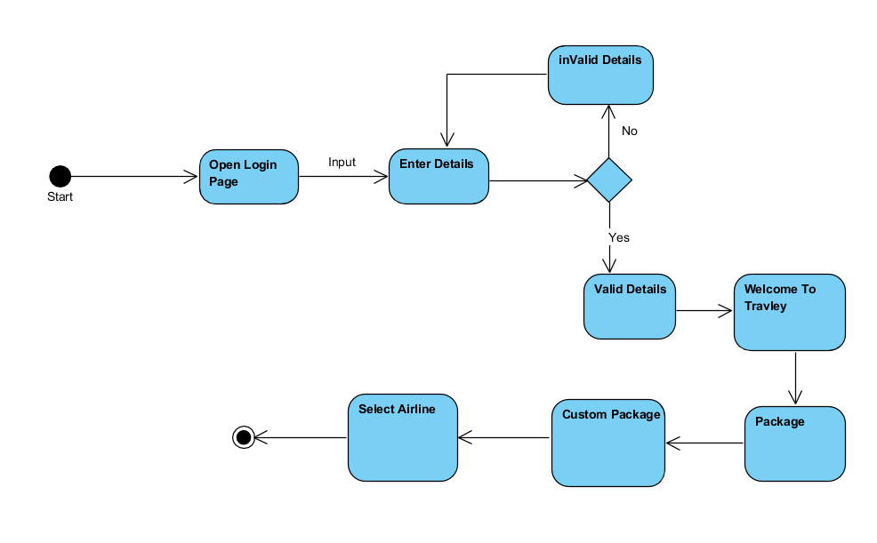

## 4.5.12. Ticket Class

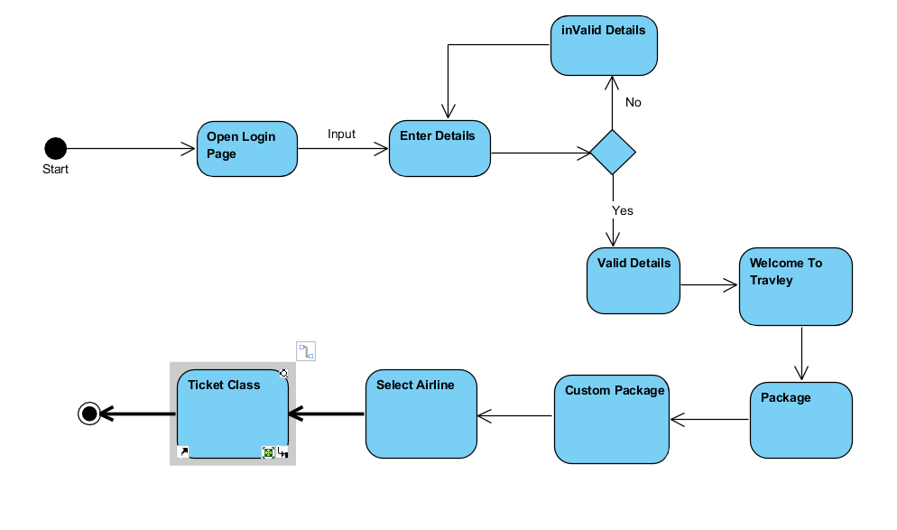

## 4.5.13. Select Hotel

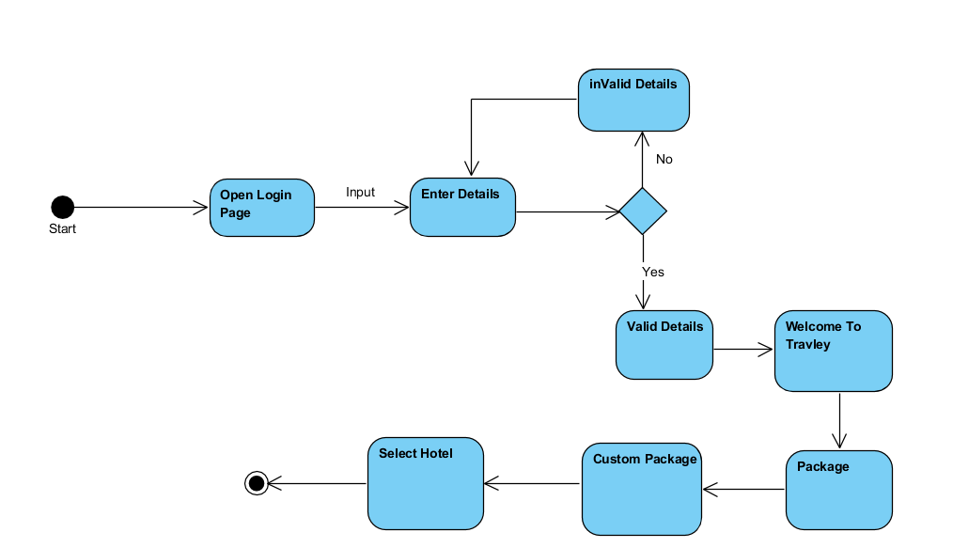

## 4.5.14. Number of Rooms

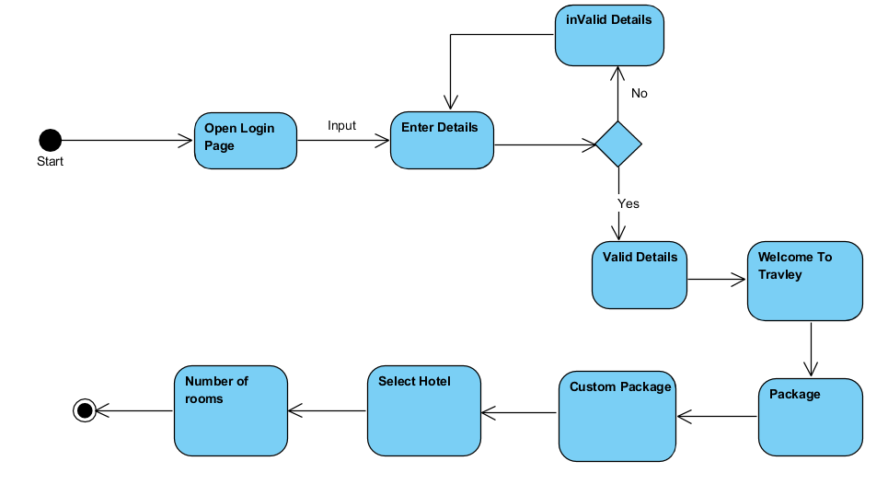

## 4.5.15. Room Type

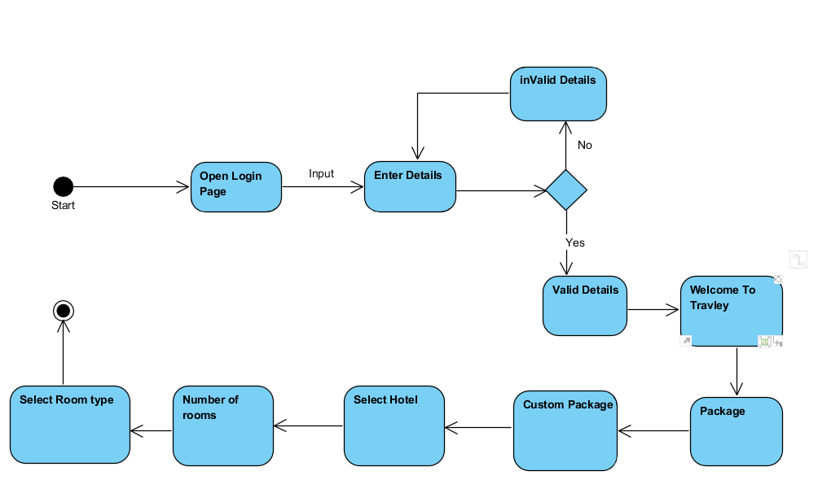

## 4.5.16. Rentals

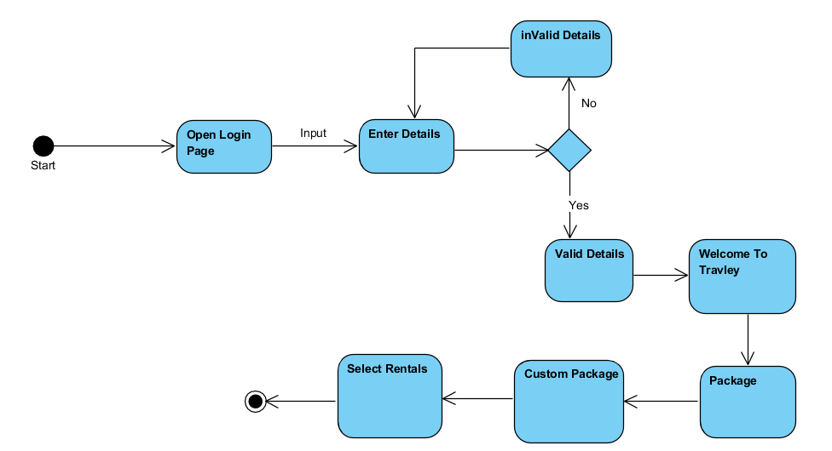

## 4.5.17. Type of Vehicle

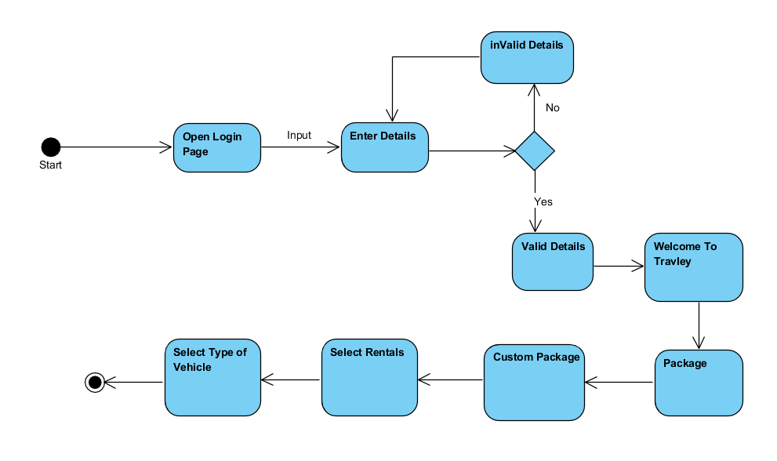

## 4.5.18. Insurance

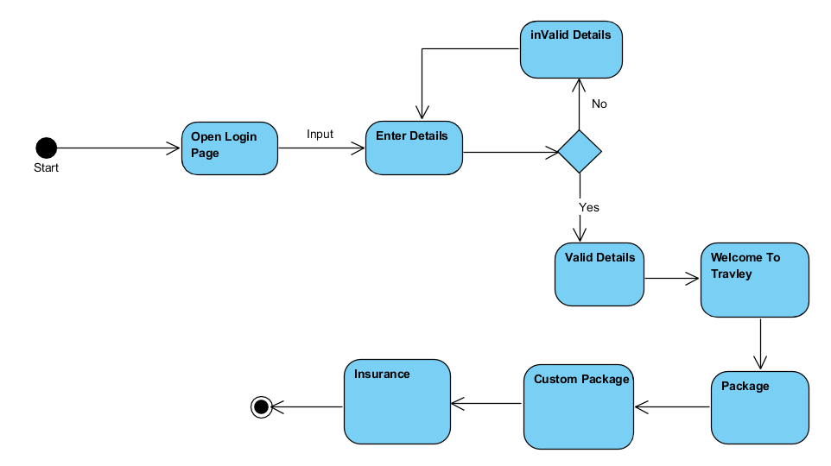

## 4.5.18. Type of Insurance

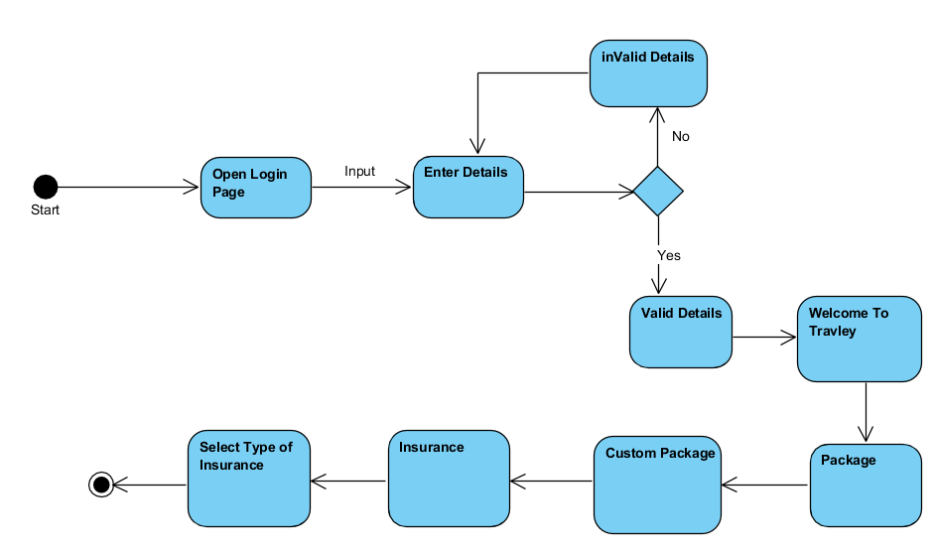

## 4.5.19. Generic Package

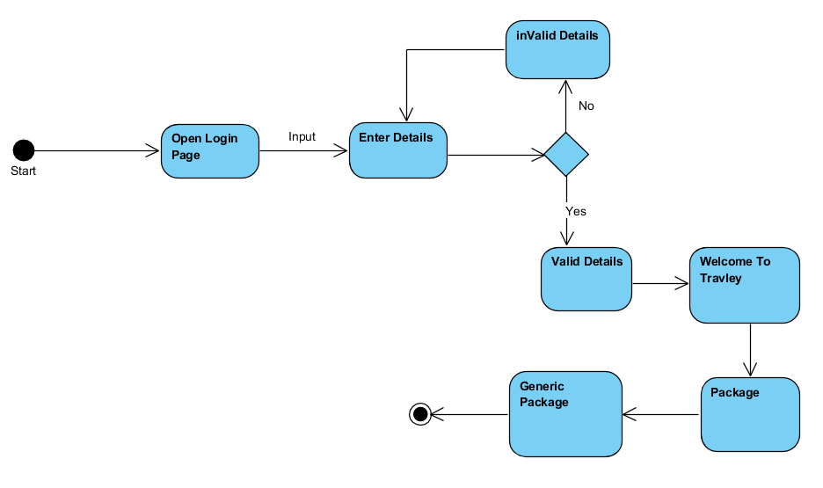

## 4.5.20. Available Packages

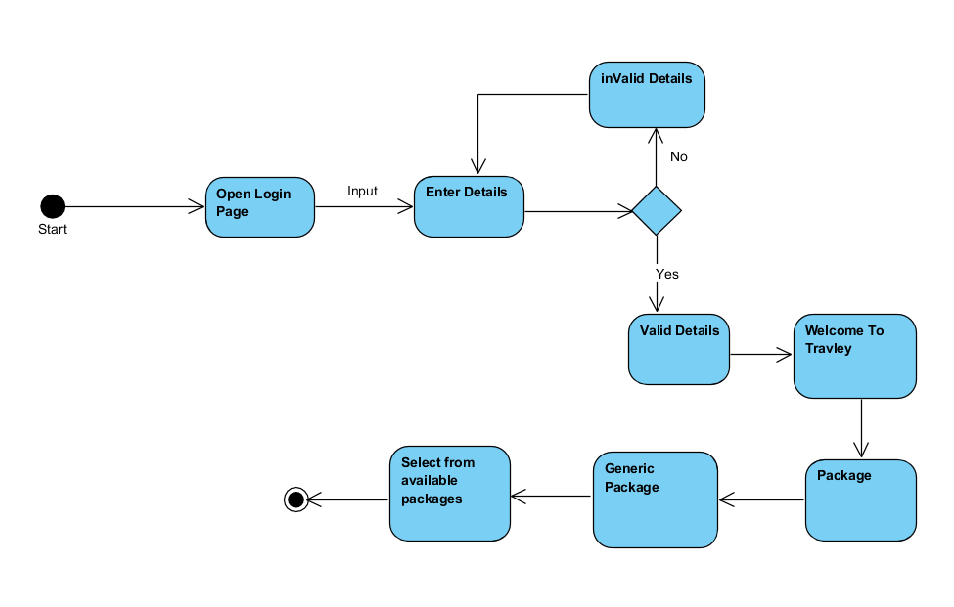

## 4.5.21. Logout

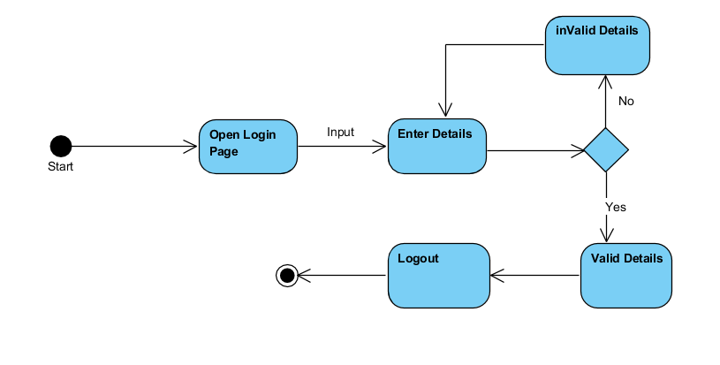

# 4.6. Sequence Diagram

## 4.6.1 Sequence diagram for register

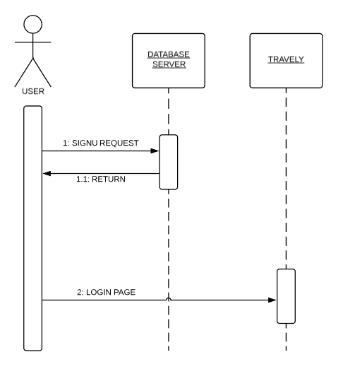

## 4.6.2 Sequence diagram for login

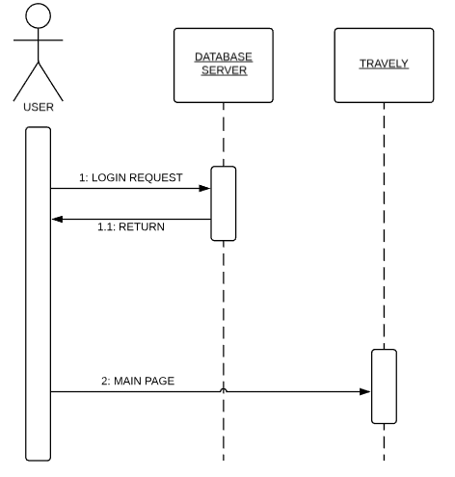

## 4.6.3 Sequence diagram for forget password

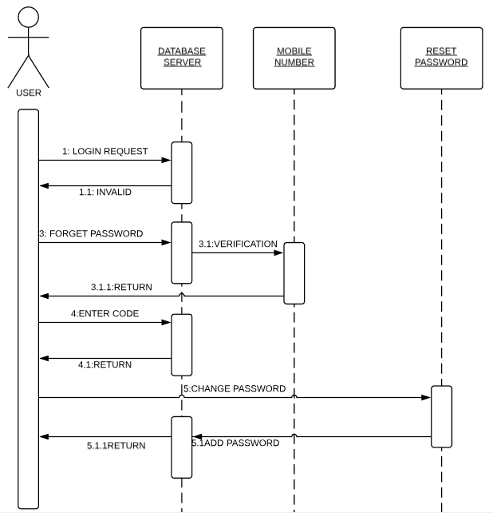

## 4.6.4 Sequence diagram for view individual package

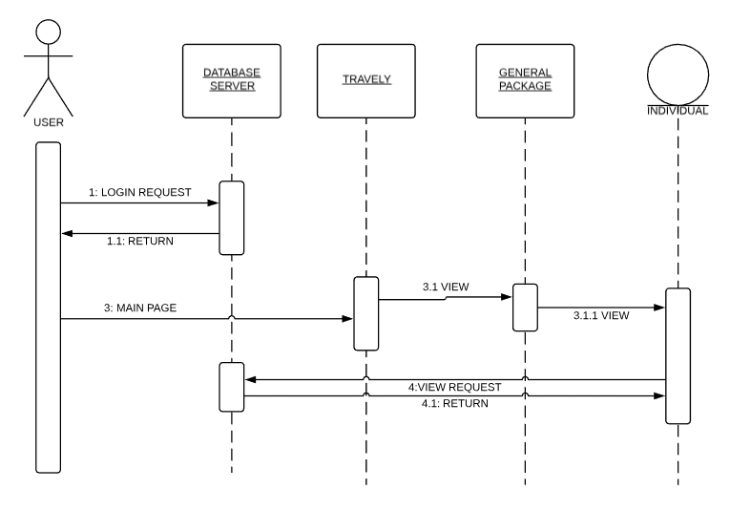

## 

## 4.6.5 Sequence diagram for admin add individual package

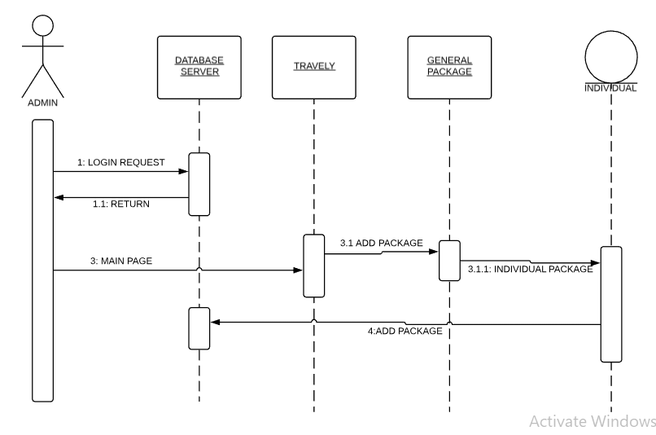

## 4.6.6 Sequence diagram for admin delete individual package

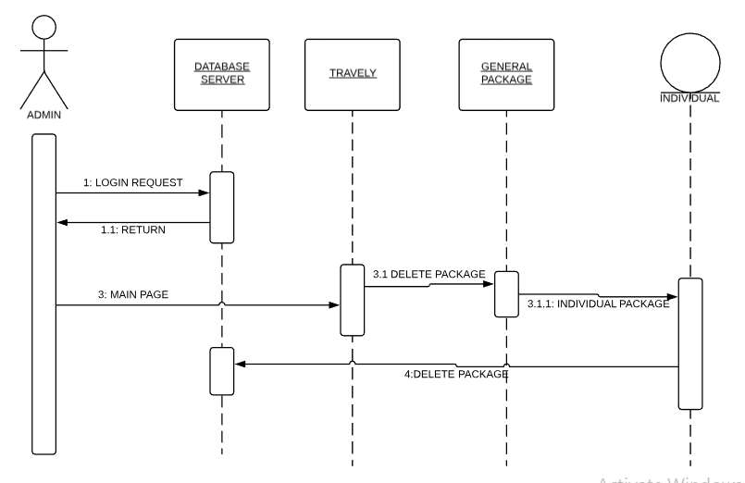

## 4.6.7 Sequence diagram for admin update individual package

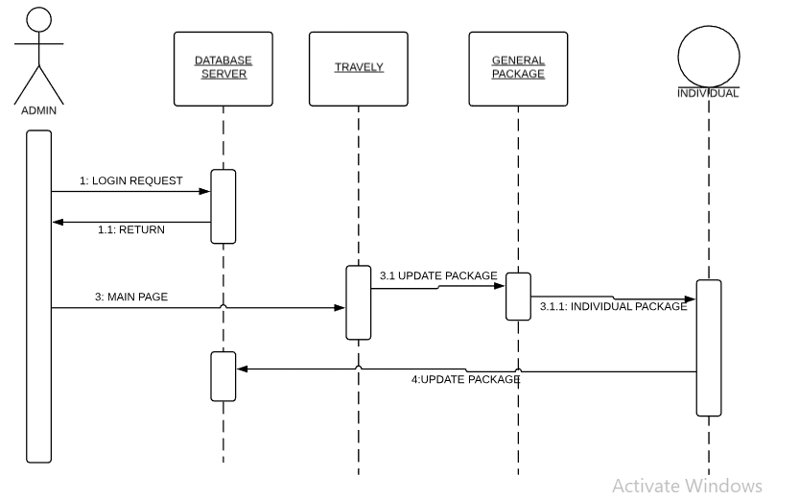

## 

## 4.6.8 Sequence diagram for view group package

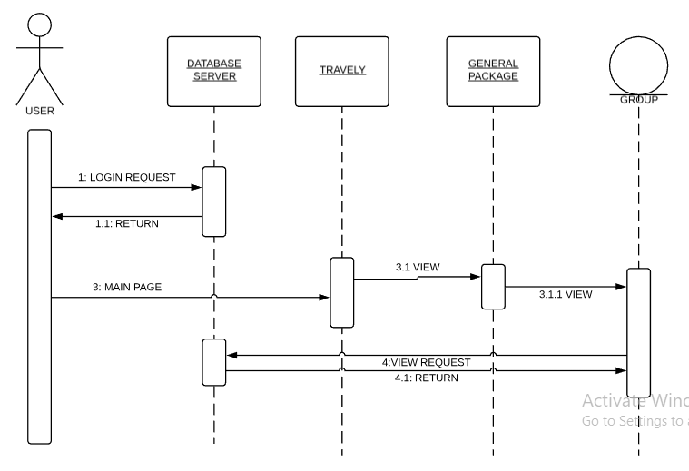

## 4.6.9 Sequence diagram for admin delete group package

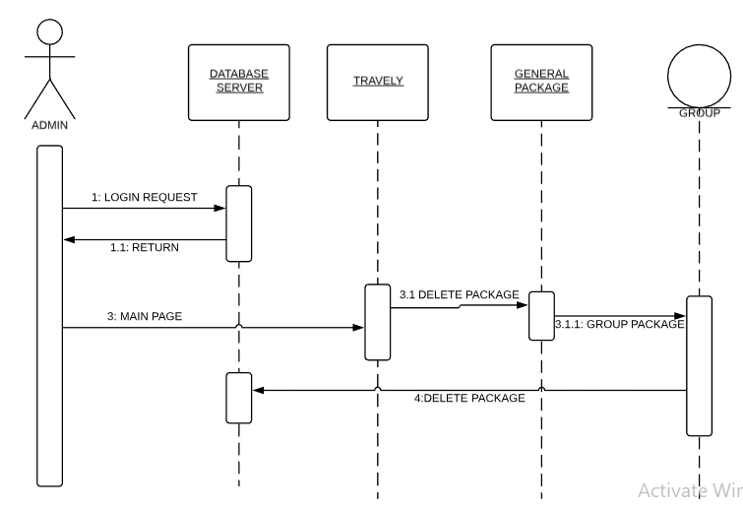

## 4.6.10 Sequence diagram for admin add group package

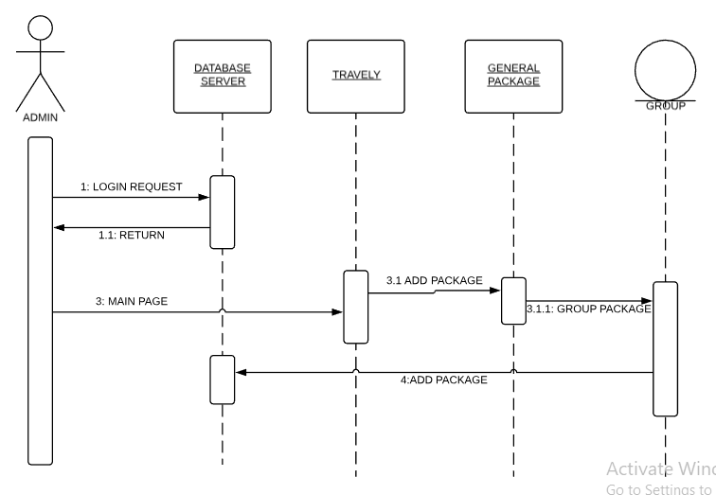

## 4.6.11 Sequence diagram for admin update group package

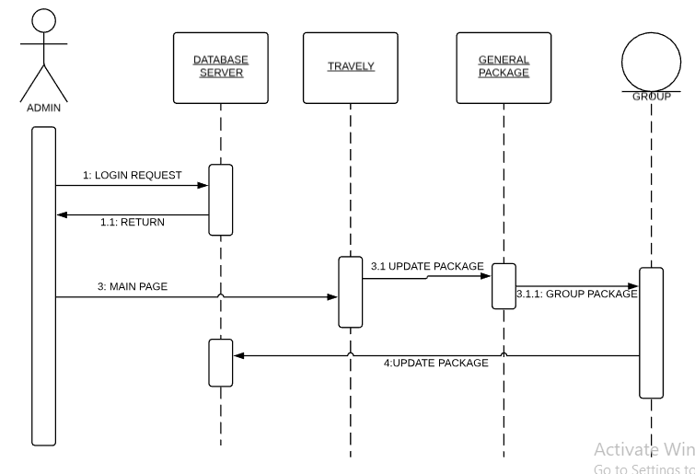

## 4.6.12 Sequence diagram for user fill his requirements

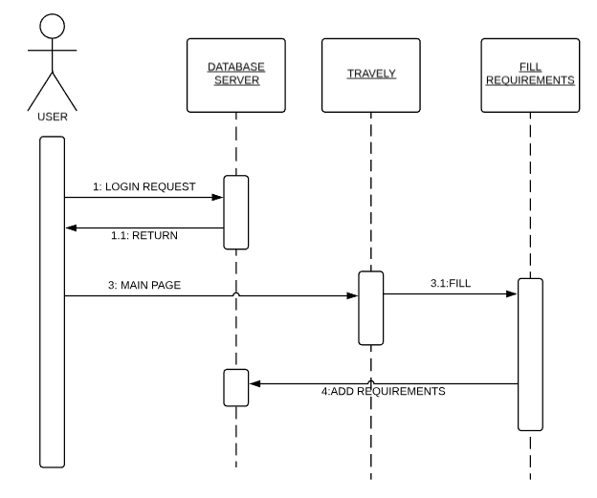

## 4.6.13 Sequence diagram for user to fill his requirements for custom packages

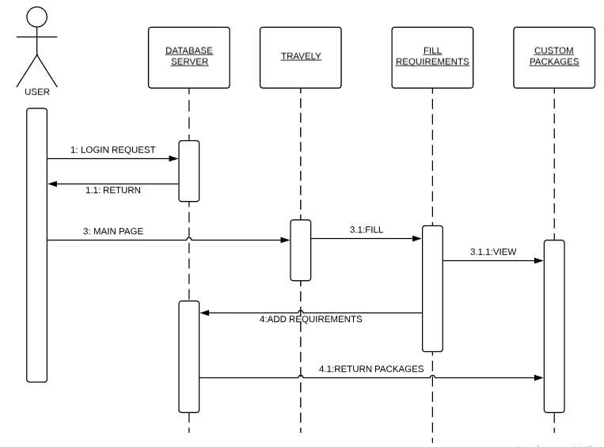

## 

## 4.6.14 Sequence diagram for user to book the custom packages

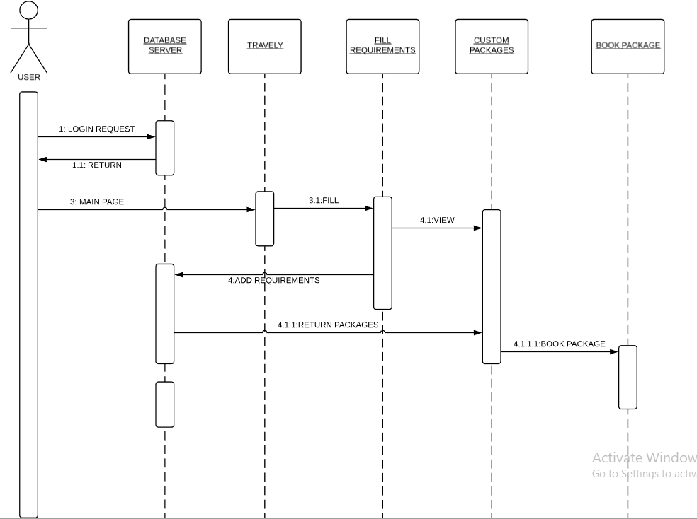

## 4.6.15 Sequence diagram for user to transfer the money

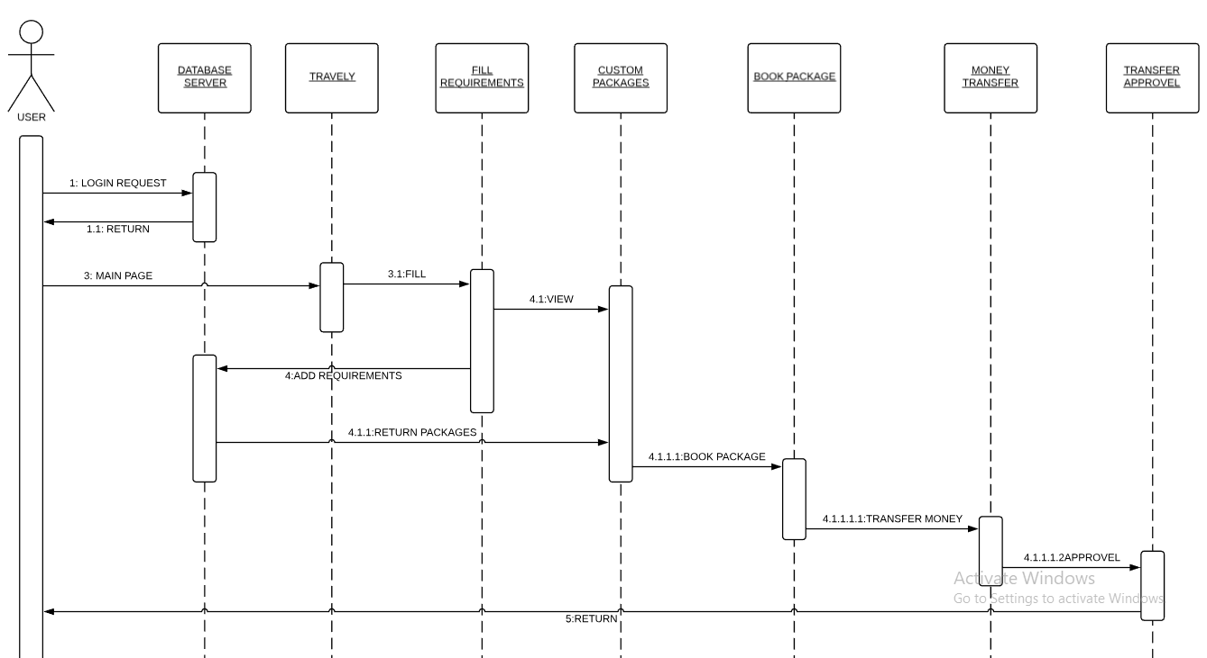

## 4.6.16 Sequence diagram for user logout

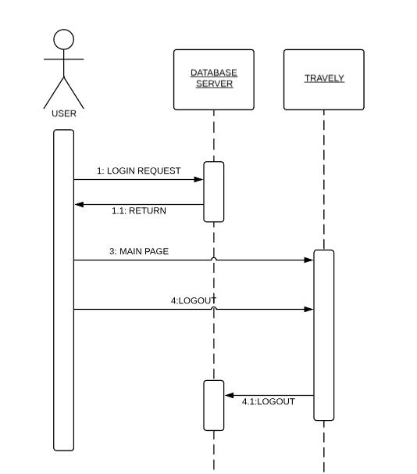

## 4.6.17 Sequence diagram for admin add the accommodation information

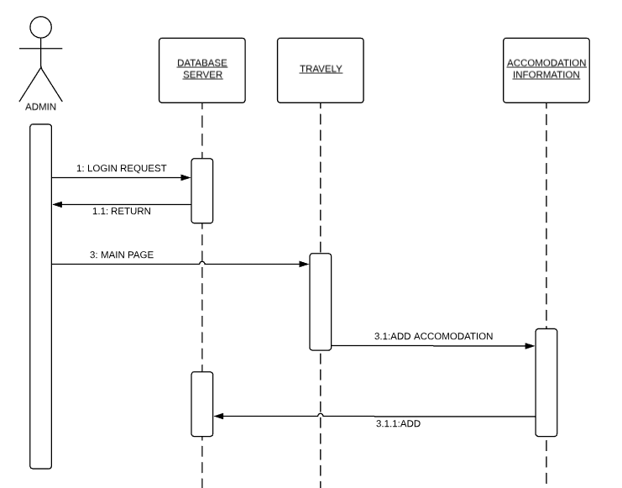

## 4.6.18 Sequence diagram for admin delete the accommodation information

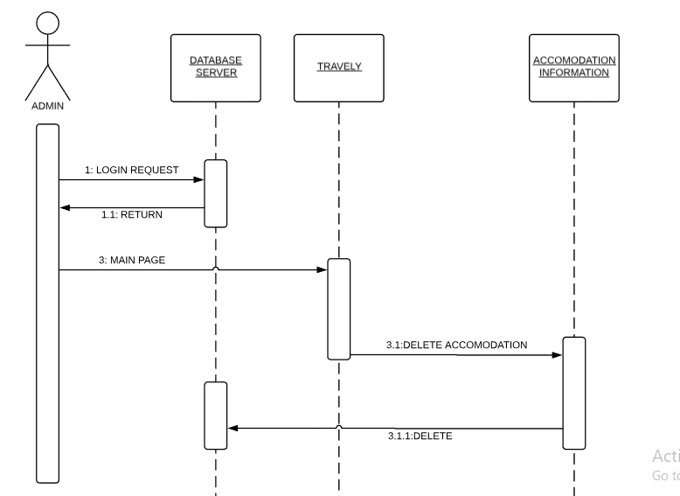

## 4.6.19 Sequence diagram for admin update the accommodation information

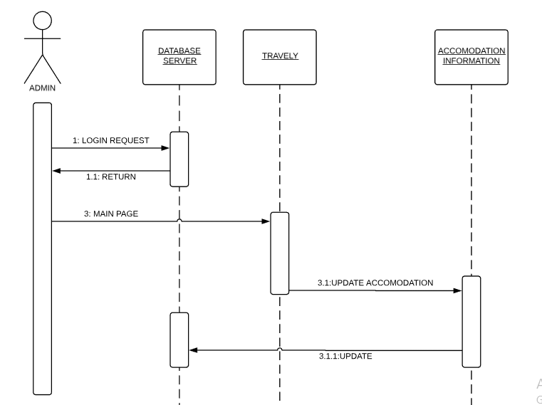

## 4.6.20 Sequence diagram for admin add the flight information

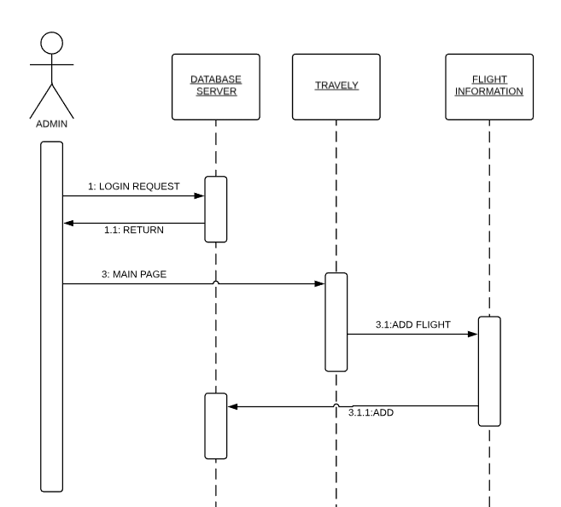

## 4.6.21 Sequence diagram for admin delete the flight information

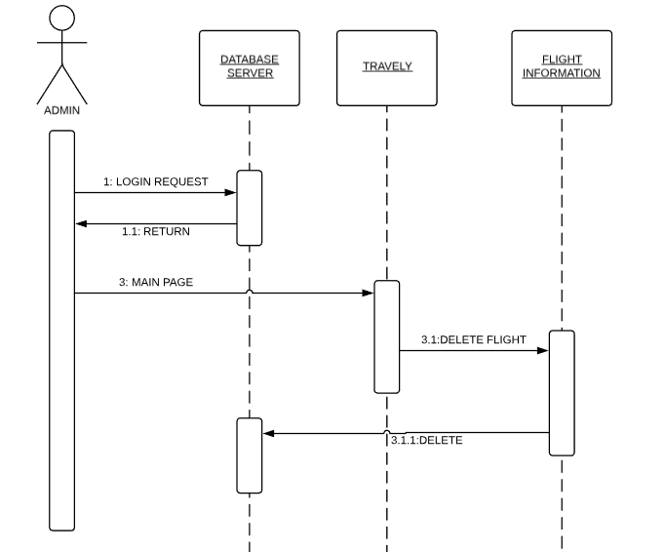

## 4.6.22 Sequence diagram for admin update the flight information

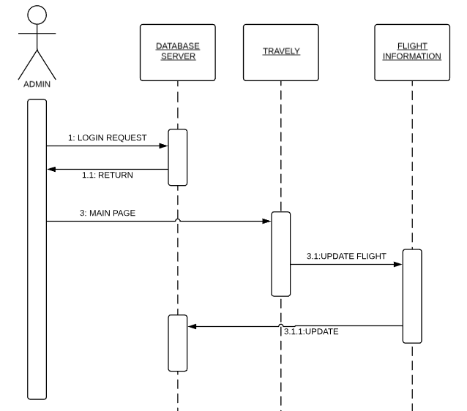

## 4.6.23 Sequence diagram for admin add the insurance information

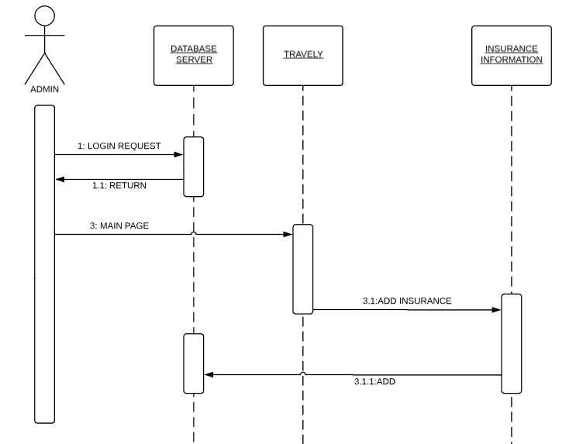

## 4.6.24 Sequence diagram for admin delete the insurance information

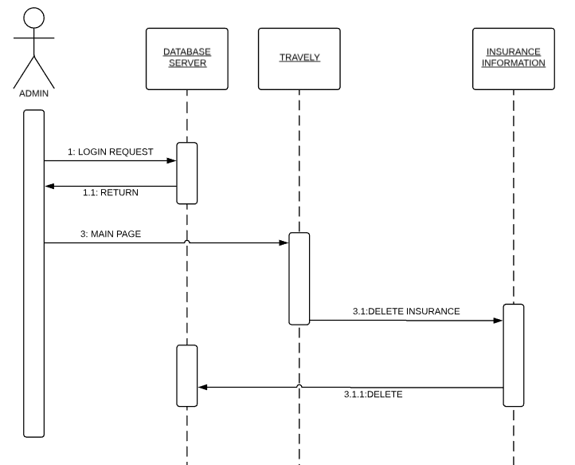

## 4.6.25 Sequence diagram for admin update the insurance information

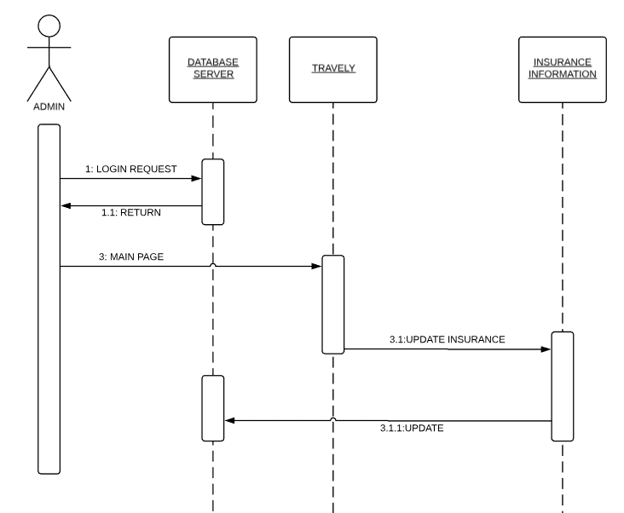

## 4.6.26 Sequence diagram for admin add the rental information

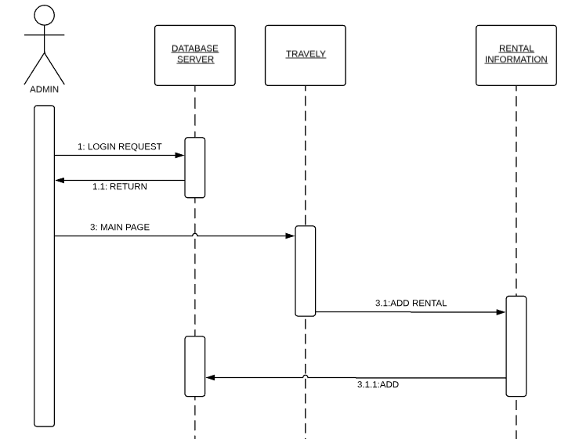

## 4.6.27 Sequence diagram for admin delete the rental information

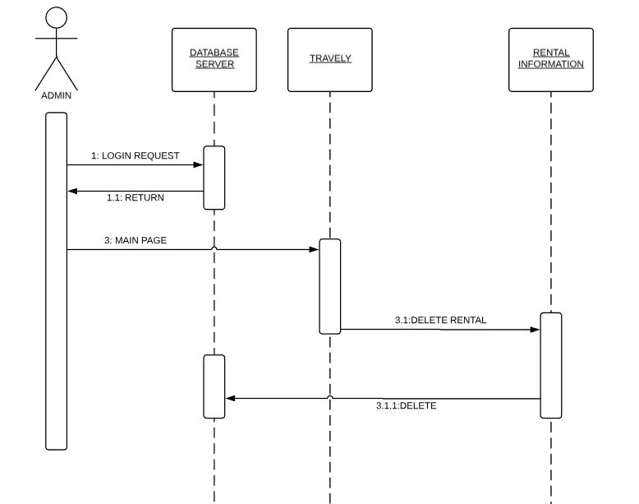

## 4.6.28 Sequence diagram for admin update the rental information

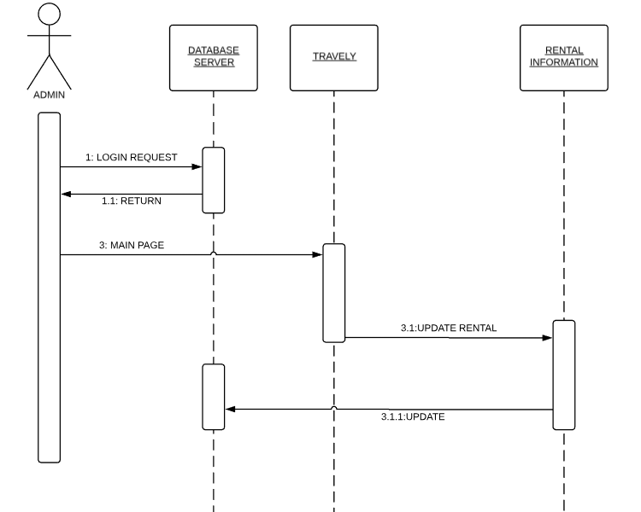

## 4.6.29 Sequence diagram for admin logout

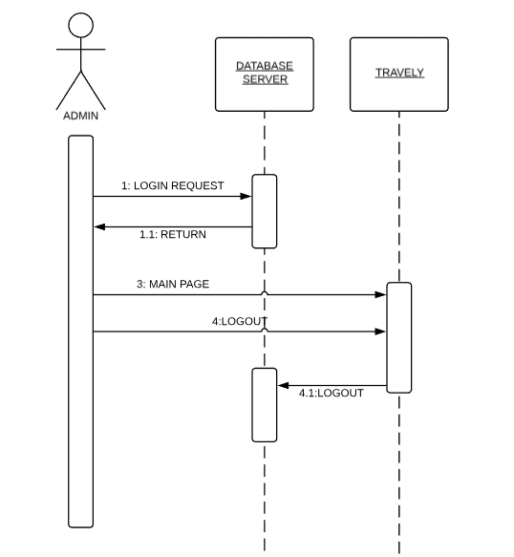

4.7. Collaboration Diagram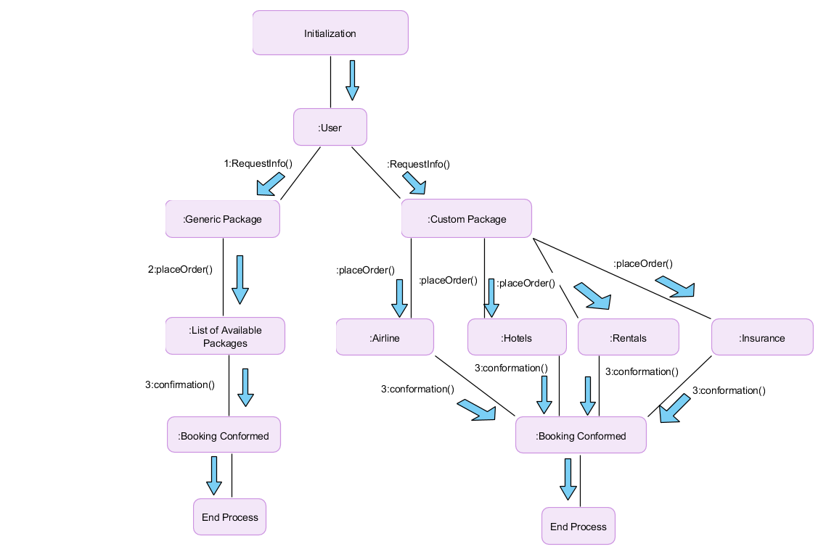

# 4.8. State Transition Diagram

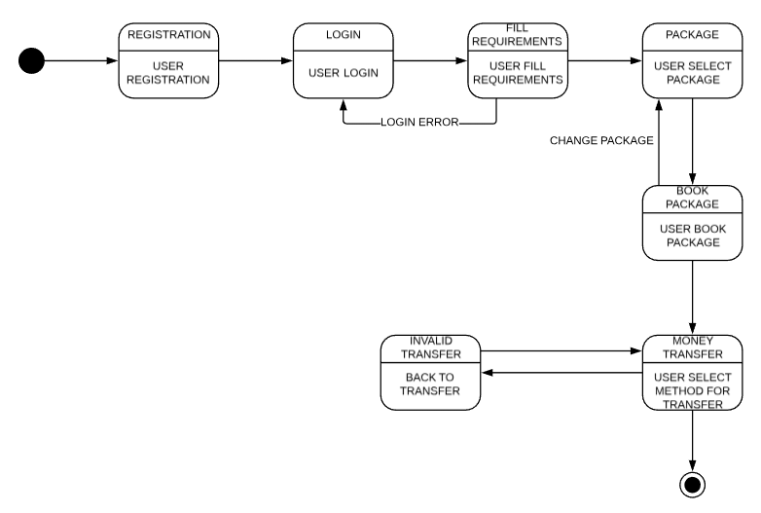

# 4.9. Component Diagram

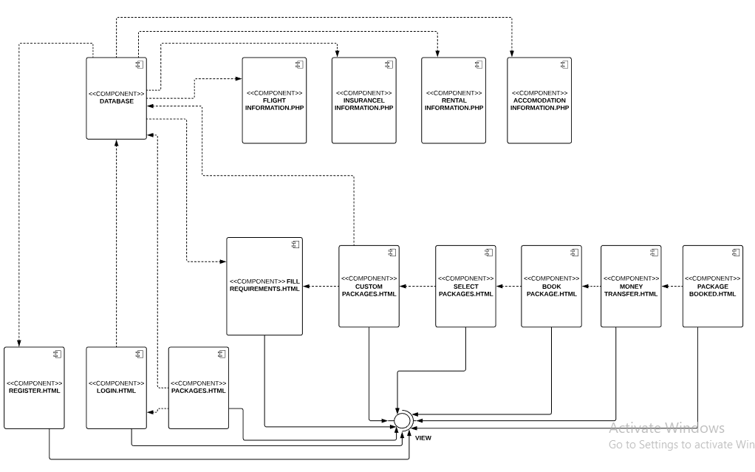

# 4.10. Deployment Diagram

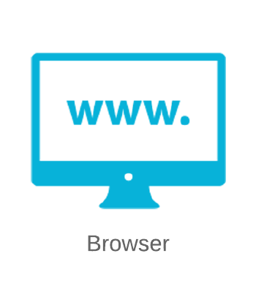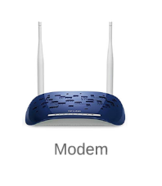 **Nodes** 